**MANAV RACHNA INTERNATIONAL**

**INSTITUTE OF REASEARCH & STUDIES**

**FACULTY OF ENGINEERING AND TECHNOLOGY**



**PRACTICAL FILE**

**FOR**

**VIIth SEMESTER (ACADEMIC YEAR 2022-2023)**

**SUBJECT NAME: ITNS Lab**

**SUBJECT CODE: BCS-DS-774**

|  |  |
| --- | --- |
| **SUBMITTED BY:-** | **SUBMITTED TO:-** |
| **STUDENT NAME: Suraj Bugade** | **FACULTY NAME: Dr. Shobha Tyagi** |
| **ROLL NO.: 1/19/FET/BCS/096** | **DEPARTMENT: CSE-FET** |
|  |  |
|  |

**INDEX**

|  |  |  |  |
| --- | --- | --- | --- |
| **PRACTICAL NO.** | **AIM OF PRACTICAL** | **DATE ON WHICH CONDUCTED** | **TEACHER’S SIGNATURE** |
|  |  |  |  |
|  |  |  |  |
|  |  |  |  |
|  |  |  |  |
|  |  |  |  |
|  |  |  |  |
|  |  |  |  |
|  |  |  |  |
|  |  |  |  |
|  |  |  |  |
|  |  |  |  |
|  |  |  |  |

**EXPERIMENT -1**

**AIM**- **Installation of virtual box and windows 7**

VirtualBox is a cross-platform virtualization application. What does that mean? For one thing, it installs on your existing Intel or AMD-based computers, whether they are running Windows, Mac, Linux or Solaris operating systems. Secondly, it extends the capabilities of your existing computer so that it can run multiple operating systems (inside multiple virtual machines) at the same time. So, for example, you can run Windows and Linux on your Mac, run Windows Server 2008 on your Linux server, run Linux on your Windows PC, and so on, all alongside your existing applications. You can install and run as many virtual machines as you like -- the only practical limits are disk space and memory.

VirtualBox is deceptively simple yet also very powerful. It can run everywhere from small embedded systems or desktop class machines all the way up to datacentre deployments and even Cloud environments.

The following screenshot shows you how VirtualBox, installed on a Mac computer, is running Windows 8 in a virtual machine window:

**STEPS FOR INSTALLATION OF VIRTUAL BOX: -**

**PART-1: CREATE THE VIRTUAL MACHINE**

**STEP-1: Download VirtualBox.** VirtualBox from Oracle is available for free from the developer's website. Make sure that you download the correct version for your operating system.

* There are multiple choices for Linux or Windows versions. Choose the package that matches your Linux or Windows distribution or use the "All distributions" option if your Linux distribution is not listed.

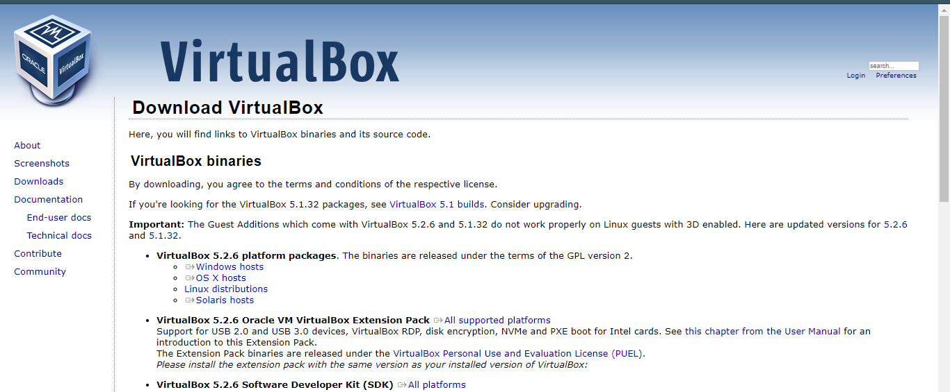

**STEP-2: Install the VirtualBox program.** If you are using Windows, double-click the setup file and follow the prompts to install. If you are using a Mac, open the DMG file that you downloaded and drag the VirtualBox file to your Applications folder.

* During the Windows installation, keep all the options set to their default.

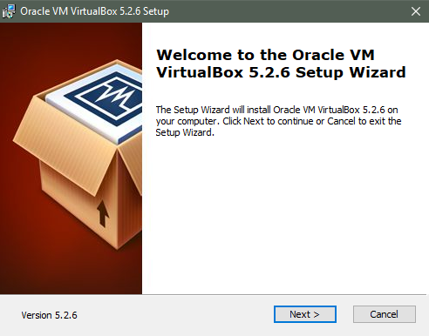

**STEP-3: Start the program.** VirtualBox allows you to manage your various virtual machines, and easily create new ones. You can run VirtualBox directly from the installation program, or you can start it from the desktop icon.

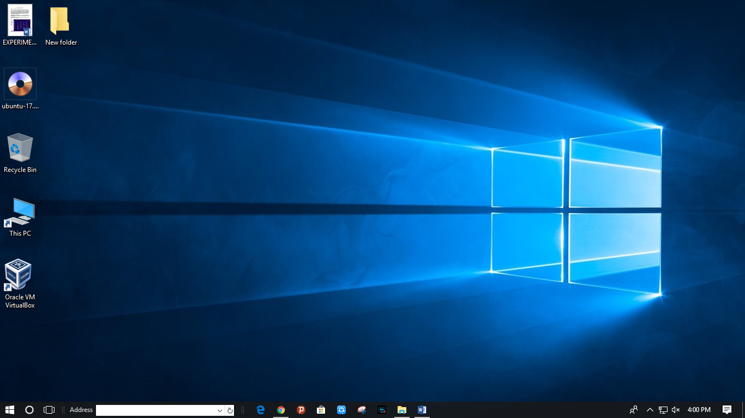

**STEP-4: Gather your installation disc(s).** When creating a virtual machine, you will need to install the operating system just like you would on a regular computer. This means that you will need the installation discs for the operating system you want to install on the virtual machine.

* If you download the ISO file for the installation disc, you can burn it to a blank DVD, or install it directly from the ISO file.

**PART-2: Windows installation in Virtual Box**

* **To Install Windows 7 inside of VMware Workstation**
* Download and install VM ware
* Insert the Windows 7 install DVD into your drive
* Run VMware Workstation 7.0 from the Start menu
* Click **New Virtual Machine**  
   [[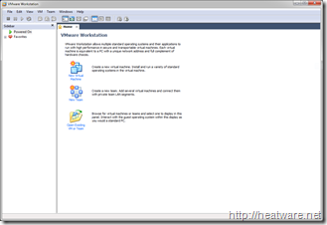](http://heatware.net/wp-content/uploads/2009/11/vmware_windows_7_14.png)](http://heatware.net/wp-content/uploads/2009/11/vmware_windows_7_14.png)
* Choose **Typical** and click **Next**

[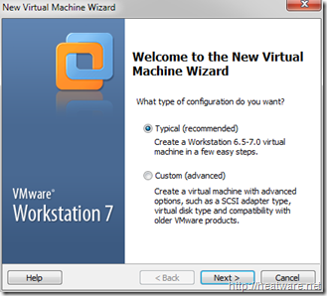](http://heatware.net/wp-content/uploads/2009/11/vmware_windows_7_2.png)

* Choose the option **Installer Disc** and ensure that the optical drive that has the Windows 7 installation DVD is selected.  
  Note: If you have Windows 7 as an ISO image, choose the option labelled: Installed disc image file (iso)

[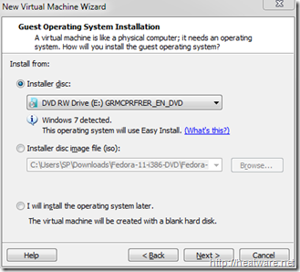](http://heatware.net/wp-content/uploads/2009/11/vmware_windows_7_3.png)

* A convenient new feature is the ability to specify your Windows 7 product key prior to starting the installation to allow for a fully-unattended install. No more coming back to your computer an hour later after you think the installation finished only to find it stuck on a screen asking for a serial number!  
  Go ahead and enter your **Windows product key**and **Full name**. The password is optional. Click **Next**.

[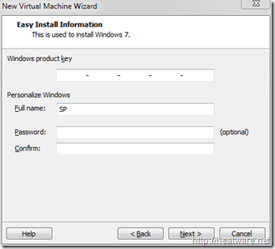](http://heatware.net/wp-content/uploads/2009/11/vmware_windows_7_4.png)

* Now it is time to name the virtual machine and choose the location. We will keep the default location and name the VM **Windows 7 Pro**

[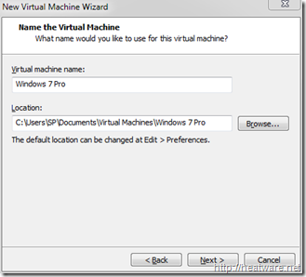](http://heatware.net/wp-content/uploads/2009/11/vmware_windows_7_5.png)

* VMware needs to know how hard drive space to allocate to the Windows 7 disk. Lets stick with the 40.0 GB default and click **Next**.

[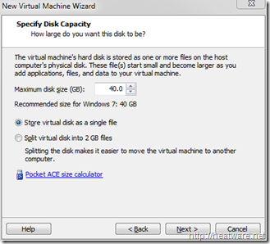](http://heatware.net/wp-content/uploads/2009/11/vmware_windows_7_6.png)

Now you will be presented with a summary screen that shows all the VM configuration parameters. Don’t worry, you can change most of these at any time! Click **Finish** to begin the installation!

[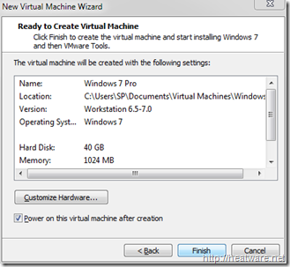](http://heatware.net/wp-content/uploads/2009/11/vmware_windows_7_7.png)

* The virtual machine will now boot up and load the Windows 7 installer from the DVD. If you need to step away from the computer, go ahead, no more user-intervention is needed.

[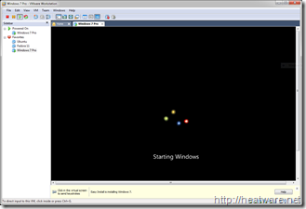](http://heatware.net/wp-content/uploads/2009/11/vmware_windows_7_8.png)

* The installer will now copy files… This will take a while…

[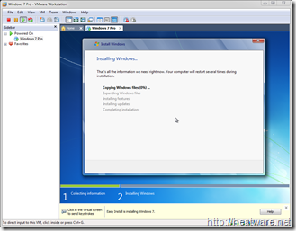](http://heatware.net/wp-content/uploads/2009/11/vmware_windows_7_9.png)

* Your system will reboot…

[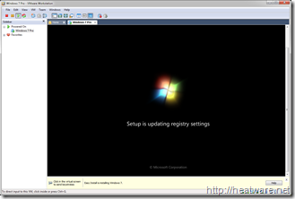](http://heatware.net/wp-content/uploads/2009/11/vmware_windows_7_10.png)

* And continue installing…

[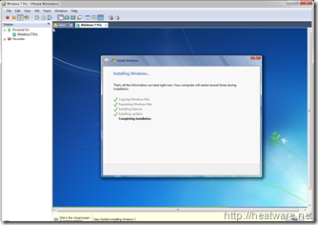](http://heatware.net/wp-content/uploads/2009/11/vmware_windows_7_11.png)

* And about 30 minutes later, its all done!

[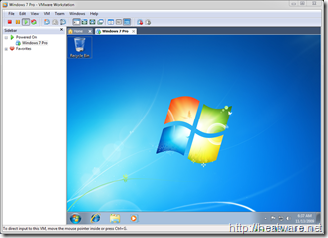](http://heatware.net/wp-content/uploads/2009/11/vmware_windows_7_12.png)

* Now is a great time to save the state of your VM by taking a snapshot. This way, if you shut down VMware, you don’t have to start all over again! Right click on *Windows 7 Pro* in the left panel and choose **Take Snapshot**

[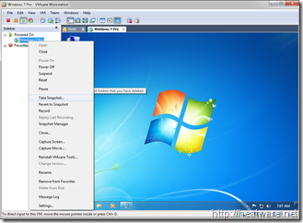](http://heatware.net/wp-content/uploads/2009/11/vmware_windows_7_13.png)

**Conclusion :**

Successful installation of Virtual Box and Windows 7.

**EXPERIMENT -2**

**AIM- Installation of Kali Linux**

Kali is an operating system based on Debian that is used by security experts called penetration testers to test the security of hardened systems. Kali comes with an extensive list of tools that you can use to test how secure your server is, ranging from testing anti-virus software to social engineering attacks and malware. This operating system is for intermediate to advance users and while it does come with the Gnome Desktop Environment, most of its features will require you to be proficient in the use of the terminal. Don’t let that scare you, the terminal is often easier and quicker than graphical user interfaces.

**Let’s get started; Install Kali Linux 2021.1:**

**Step 1: Create a USB installer**

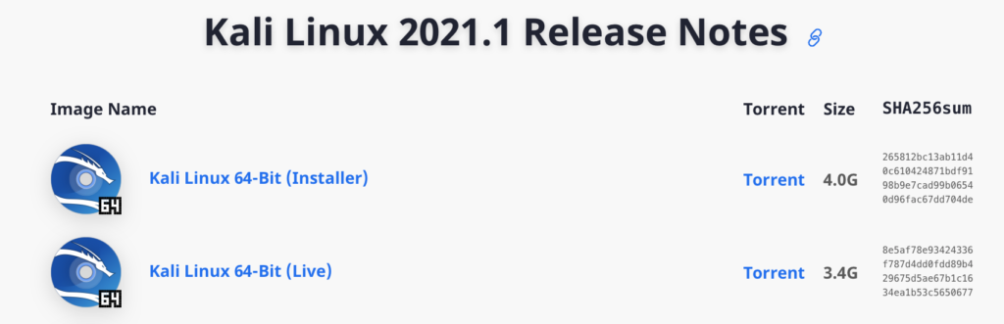

First thing is first, you are going to need to boot into a USB installer to start the installation process. This involves two parts; first, download a copy of Kali Linux 2021.1 from their [Official Website](https://www.kali.org/downloads/). There are two versions of the ISO, one is an installer, the other is for the live version of kali. Choose the one labelled installer.

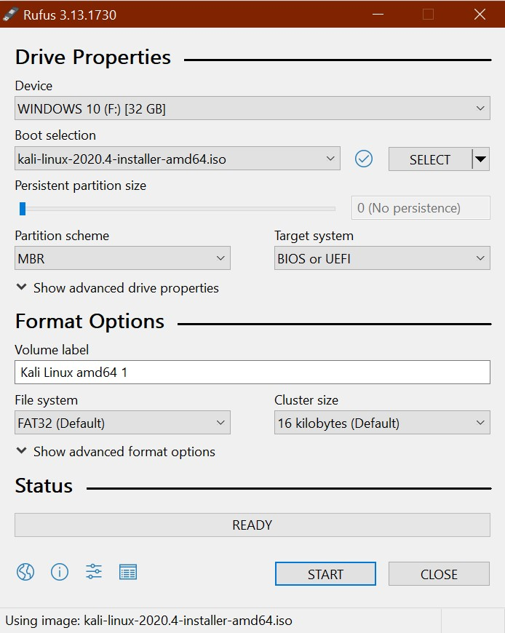

Then download [Rufus](https://rufus.ie/) which is the tool you will need to create your USB installer with a few simple clicks. [Click here](https://github.com/pbatard/rufus/releases/download/v3.13/rufus-3.13.exe) to download version 3.13 of Rufus or go to [Rufus.ie](https://rufus.ie/) and download the latest version.

***Step 2: Boot to the USB drive***

Make sure your recently created USB installer is plugged into the computer you would like to install Kali Linux 2021.1 into then power it on and as it boots continuously tap either the F10 or F12 (depends on your computer) function key on your keyboard to enter the boot menu then choose your USB drive to boot into.

***Step 3: Start the installation***

The Kali USB installer unlike many Linux distro’s does not come with a version of the operating system already installed on the USB drive called “live USB”. If you would like to run Kali as a live USB you will need to create a bootable USB from the live ISO available on the Kali Downloads page.

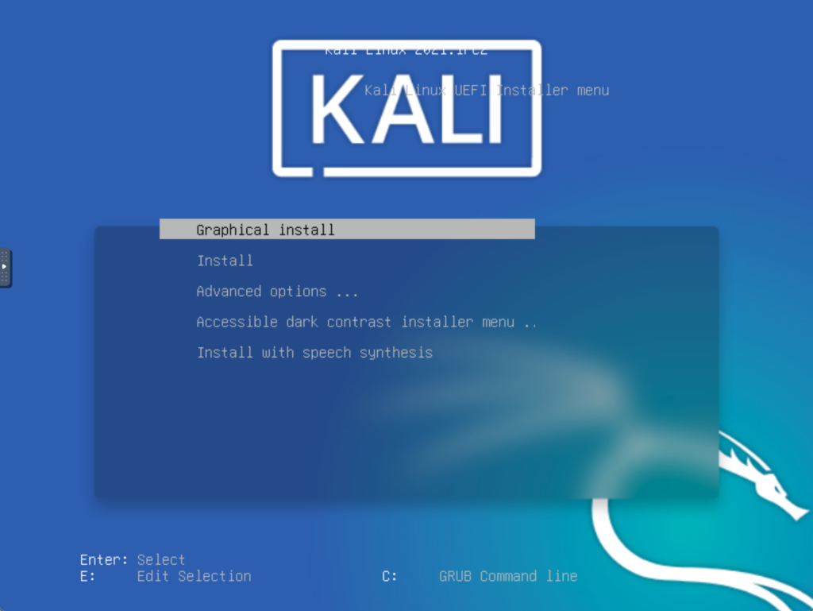

You can choose “Graphical install” to get started; If you run into any problems then select the regular “Install” option.

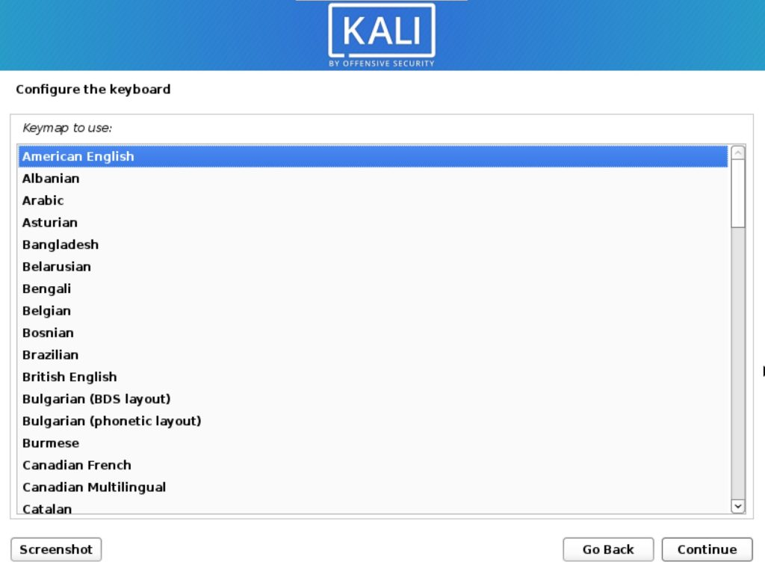

Next, pick your desired language and click continue. Then choose your location before you continue; then choose your keyboard layout and go through any other options you are prompted with.

***Step 4: Choose some options***

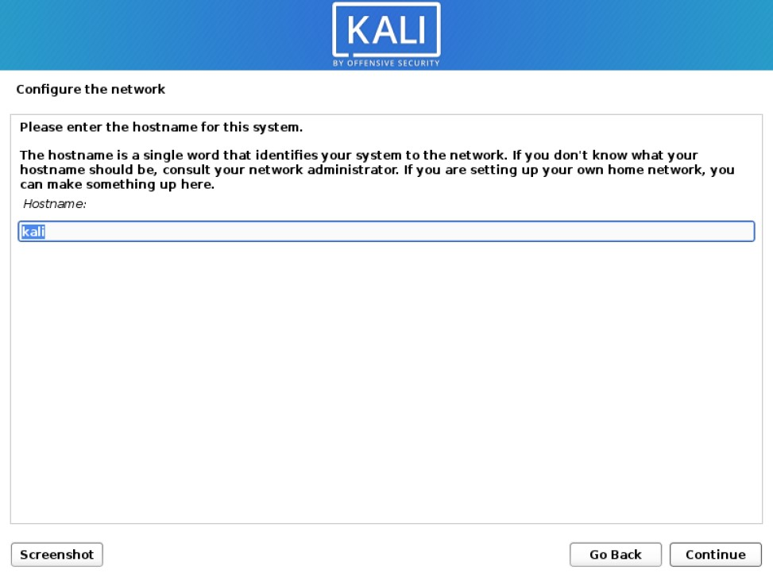

Enter your desired hostname then move on to the next option; a hostname is what identified your computer to the network you connect to.

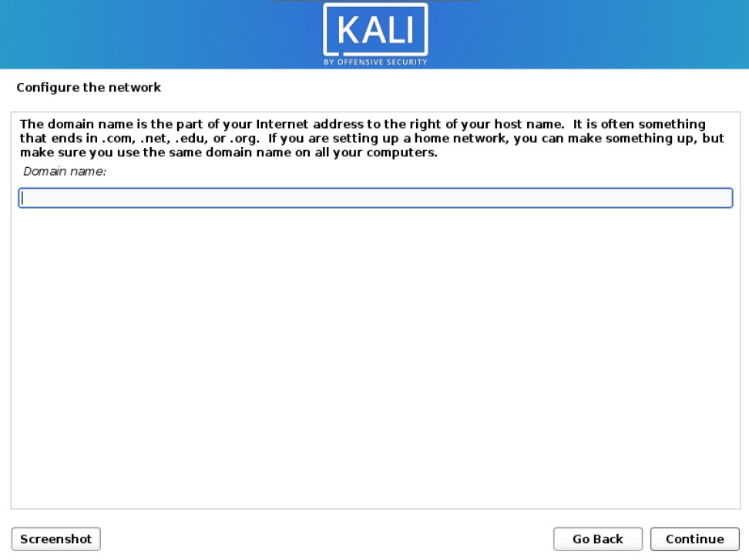

Enter a domain name here if you would like to or leave it blank if you do not have one;

Since Kali 2020.1 you are required to create a Non-Root user which will serve as the default user instead of the traditional root from versions of Kali prior to 2020.1. After installation, if you prefer to use Root you can activate it and set a password if that is the direction you would like to go.

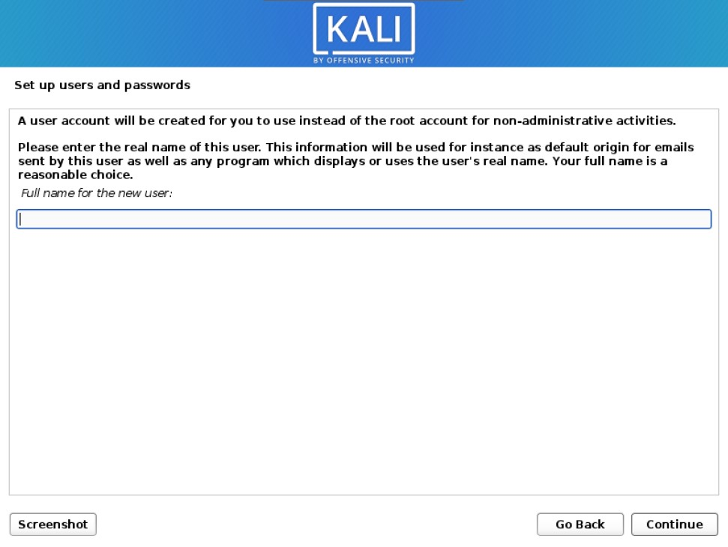

For now enter your desired name, followed by a username, and finally a password.

***Step 5: Partition the Drive***

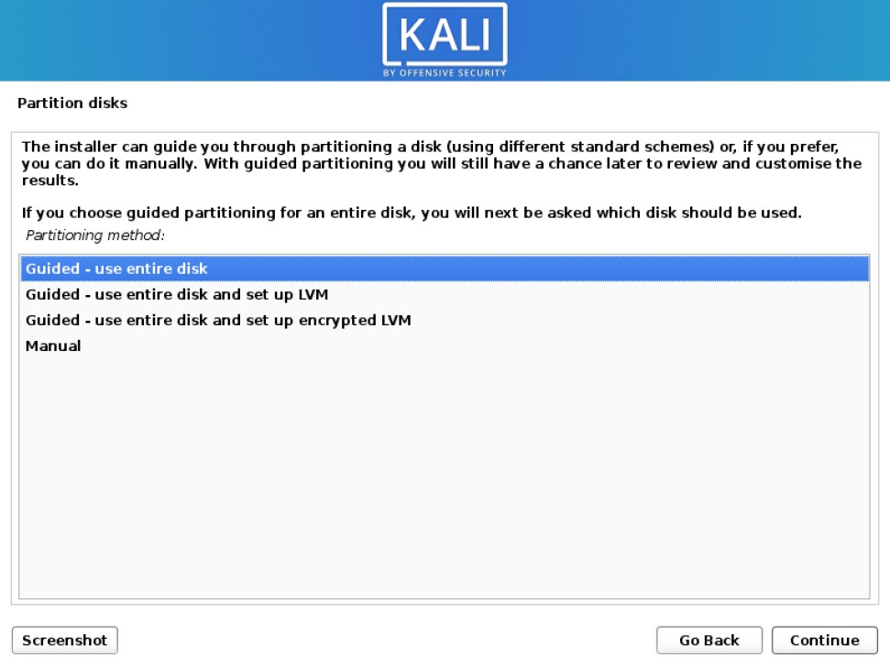

Here you may choose partition options and you may choose to enable and configure whole disk encryption or LVM (logical volume management) or customize your partitions to your own liking. For most people, the default options are probably going to be just fine. Click continue then follow the onscreen instructions to confirm the partition you have chosen.

***Step 6: Finalize the Installation***

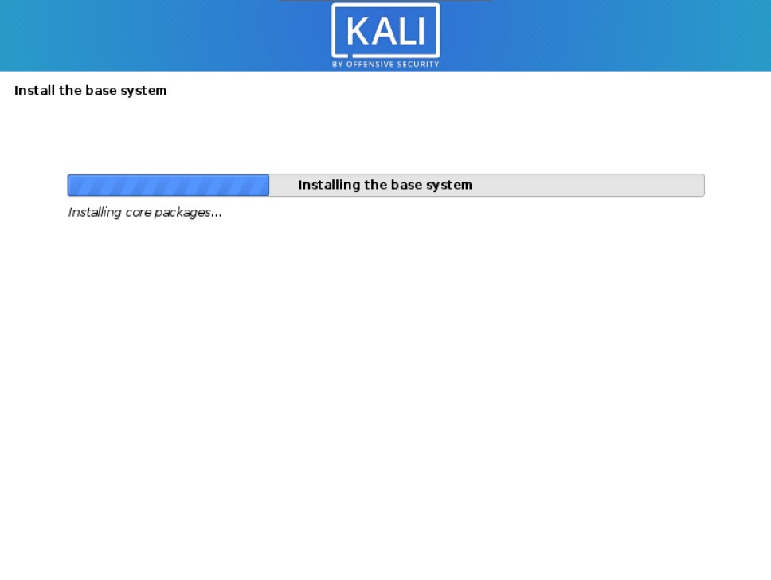

Your installation has begun now, note that this will take several minutes depending on how fast your system is.

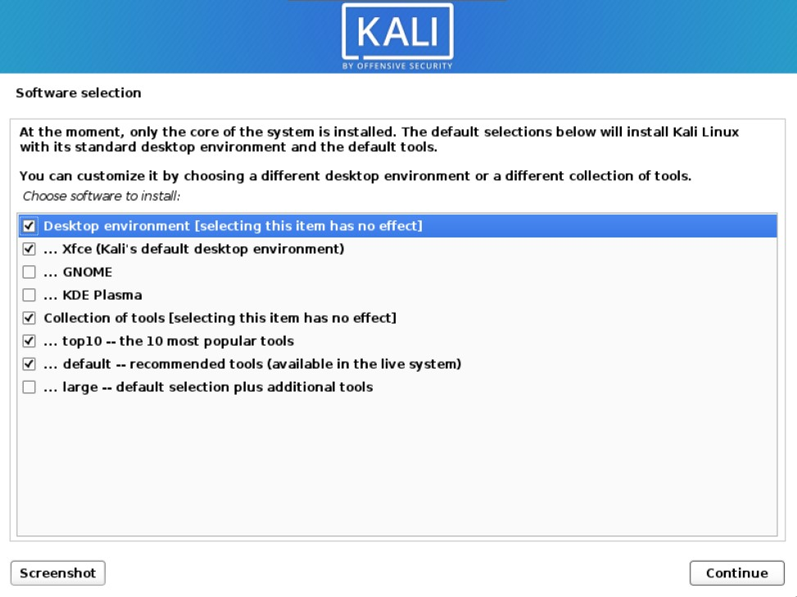

You will be prompted with some software options, which include desktop environments, and what tools you would like to install. Do note that you can install these tools later should you change your mind. Or find that you require more tools than you originally had chosen at installation. XFCE is Kali’s default desktop environment, but you can choose GNOME or KDE plasma if you prefer.

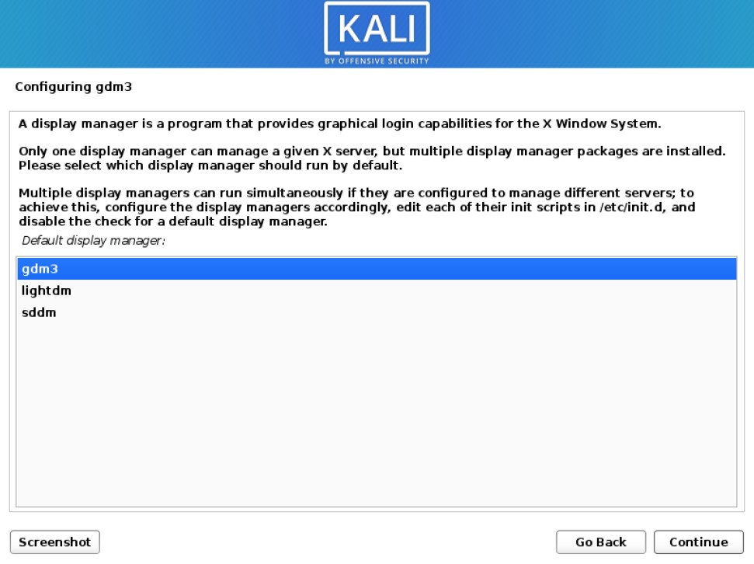

Shortly after you may be prompted to choose a display manager. This may occur if you have chosen to install more than one desktop environment. Select whichever display manager you like best and click continue.

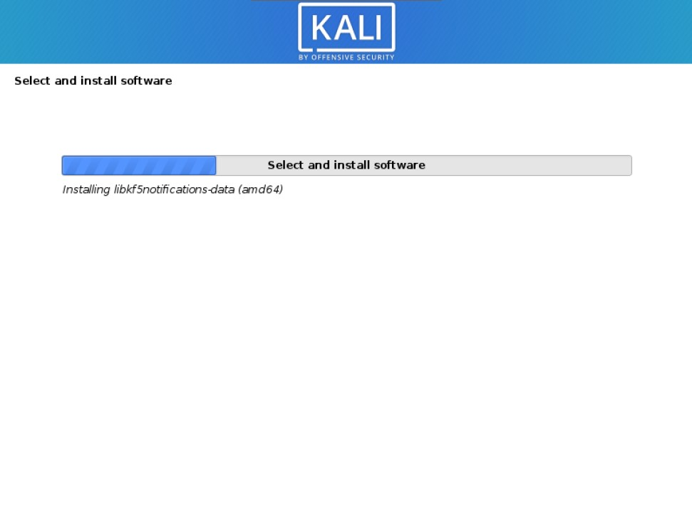

The installation will then continue; this should take a few more minutes depending on how fast your system is. When your installation is complete you will be prompted to restart your system. Click continue and in no time you will be greeted with a login prompt.

#### **Welcome to your Desktop;**

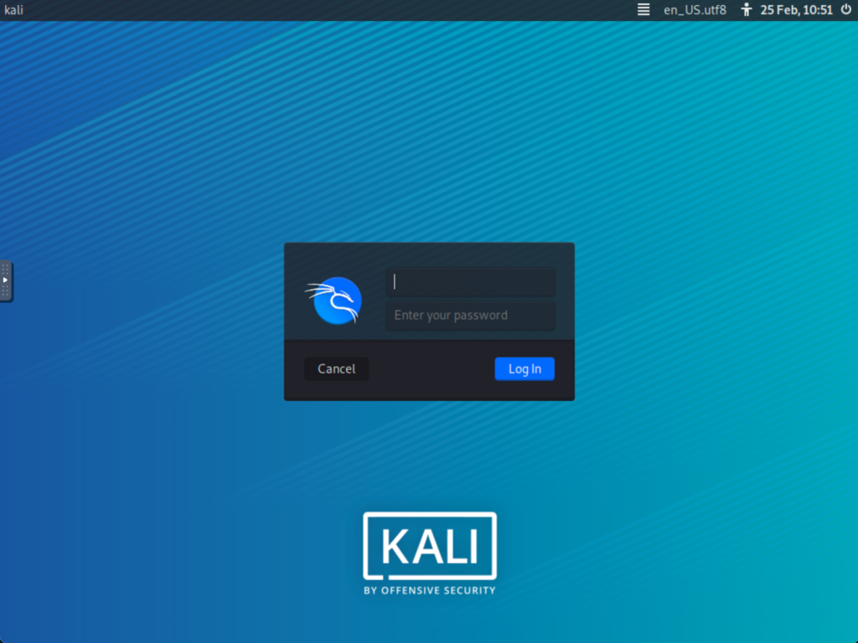

Your installation does not immediately boot up, it does require that you first key in a username and password. Use the username and password you set earlier during setup;

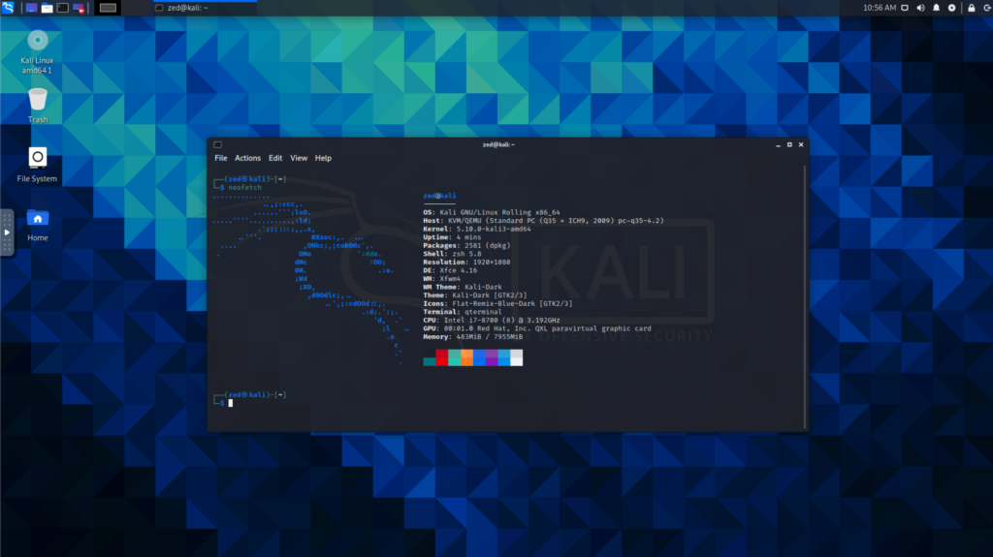

Now that you have installed Kali Linux you can log in. Next, you will be greeted by the desktop environment that you have chosen during installation.

**Conclusion :**

Successful installation of Kali operating system.

**EXPERIMENT – 3**

**AIM** – **To implement different commands using NMAP**

**Theory**

Nmap (“Network Mapper”) is a free and open source (license) utility for network discovery and security auditing. Many systems and network administrators also find it useful for tasks such as network inventory, managing service upgrade schedules, and monitoring host or service uptime. Nmap uses raw IP packets in novel ways to determine what hosts are available on the network, what services (application name and version) those hosts are offering, what operating systems (and OS versions) they are running, what type of packet filters/firewalls are in use, and dozens of other characteristics. It was designed to rapidly scan large networks, but works fine against single hosts.

Nmap is:

* Flexible: Supports dozens of advanced techniques for mapping out networks filled with IP filters, firewalls, routers, and other obstacles. This includes many port scanning mechanisms (both TCP & UDP), OS detection, version detection, ping sweeps, and more.
* Powerful: Nmap has been used to scan huge networks of literally hundreds of thousands of machines.
* Portable: Most operating systems are supported, including Linux, Microsoft Windows, FreeBSD, OpenBSD, Solaris, IRIX, Mac OS X, HP-UX, NetBSD, Sun OS, Amiga, and more.
* Easy: While Nmap offers a rich set of advanced features for power users, you can start out as simply as “nmap -v -A targethost”. Both traditional command line and graphical (GUI) versions are available to suit your preference. Binaries are available for those who do not wish to compile Nmap from source.

**Steps**:

1. Start the nmap tool in the terminal by writing the command pseudo nmap.
2. To Scan a System with Hostname and IP address write the command in the terminal pseudo nmap google.com or give the IP address of the desired target.
3. We can use -v command to get more detailed information about the remote machines.
4. Nmap also have the feature to scan multiple hosts at a time. Command used: pseudo nmap <multiple IP addresses of different websites>.
5. Nmap can also be used to identify hostnames of the given IP’s by using the command pseudo nmap -sL <Random IP Address>.
6. Nmap also have a command -A which indicates Aggressive it will let Us Know The Extra Information’s like OS Detection (-O), version detection, script scanning (-sC), and traceroute (–traceroute) even it provides a lot of valuable information About The Host.
7. Implement all the above mentioned commands in the Kali Linux Terminal.

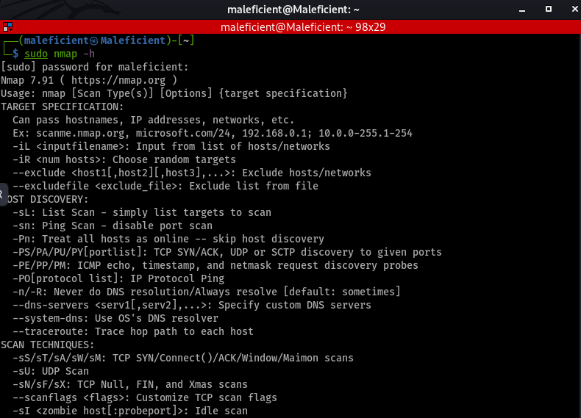

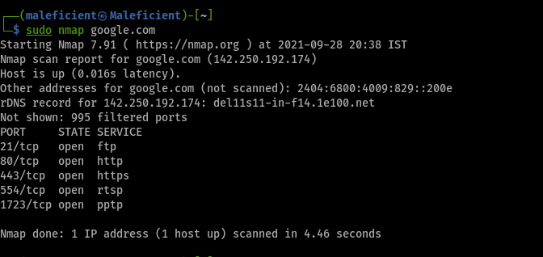

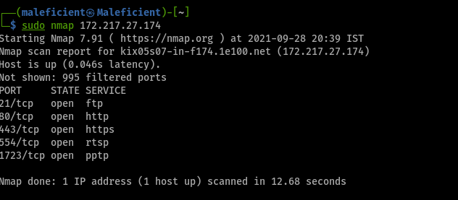

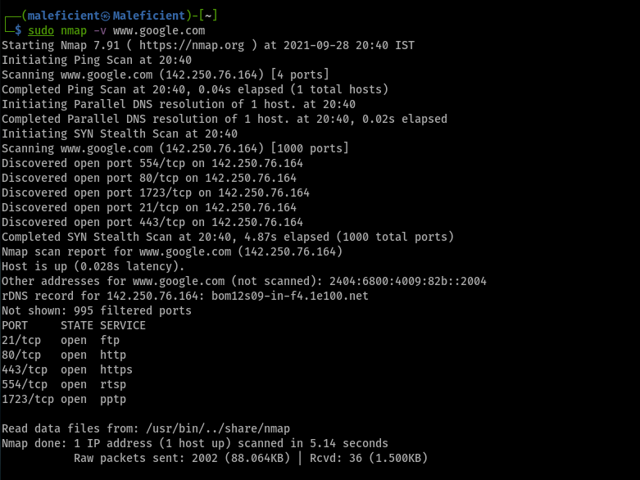

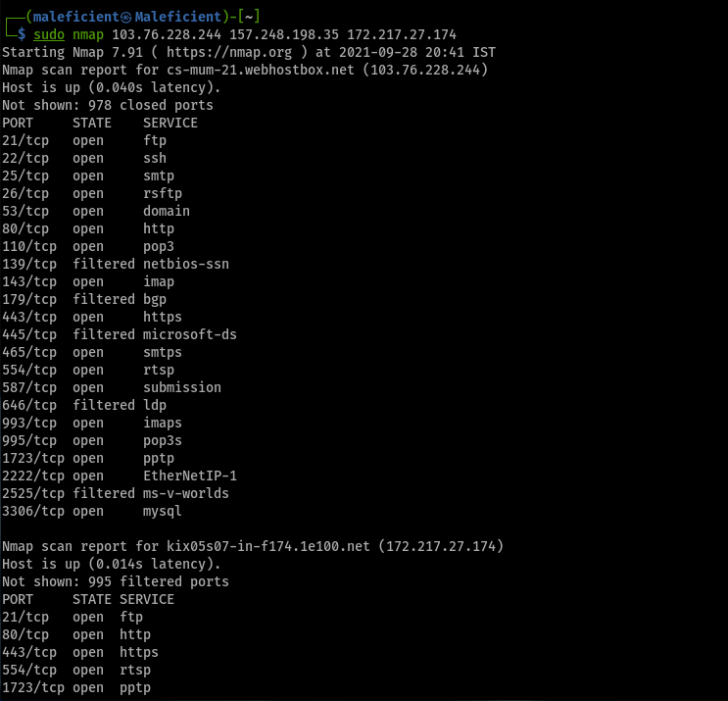

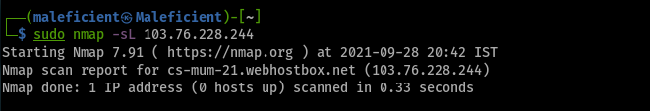

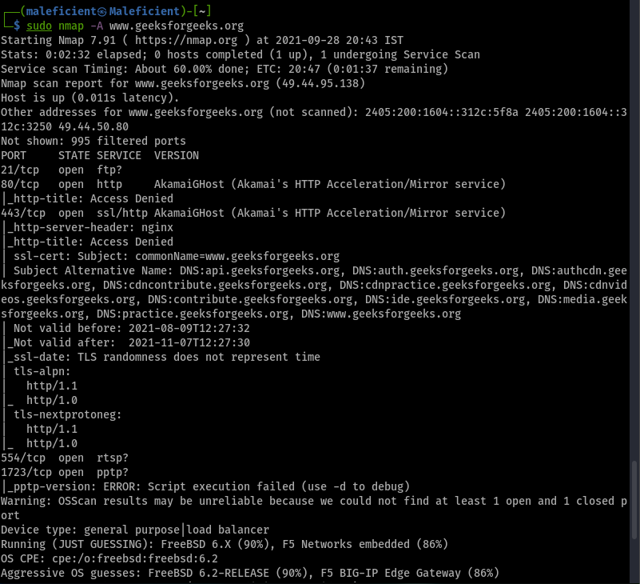

**Conclusion :**

-V, -A commands have been implemented using NMAP.

**EXPERIMENT – 4**

**AIM** – To perform vulnerability scanning using Nessus tool.

**Theory**

**What is Nessus?**

Nessus is a remote security scanning tool, which scans a computer and raises an alert if it discovers any vulnerabilities that malicious hackers could use to gain access to any computer you have connected to a network. It does this by running over 1200 checks on a given computer, testing to see if any of these attacks could be used to break into the computer or otherwise harm it.

**Why Nessus?**

If you are familiar with other network vulnerability scanners, you might be wondering what advantages Nessus has over them. Key points include:

* + Unlike other scanners, Nessus does not make assumptions about your server configuration (such as assuming that port 80 must be the only web server) that can cause other scanners to miss real vulnerabilities.
  + Nessus is very extensible, providing a scripting language for you to write tests specific to your system once you become more familiar with the tool. Its also provides a plug-in interface, and many free plug-ins are available from the Nessus plug-in site. These plugs are often specific to detecting a common virus or vulnerability.
  + Up to date information about new vulnerabilities and attacks. The Nessus team updates the list of what vulnerabilities to check for on a daily basis in order to minimize the window between an exploit appearing in the wild, and you being able to detect it with Nessus.
  + Open-source. Nessus is open source, meaning it costs nothing, and you are free to see and modify the source as you wish.
  + Patching Assistance: When Nessus detects a vulnerability, it is also most often able to suggest the best way you can mitigate the vulnerability.

**STEPS**:

1. Create a Scan. To create a scan go to top navigation bar and click Scans or go to upper right corner of the My Scans page, click on the New Scan button.
2. Choose a Scan Template. Click the scan template you want to use. Scan templates simplify the process by determining which settings are configurable and how they can be set.
3. Configure Scan Settings.

**Practical**

**OUTPUT:**

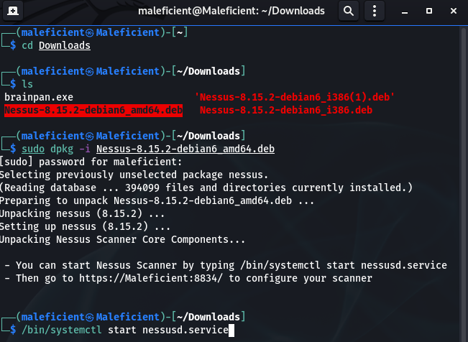

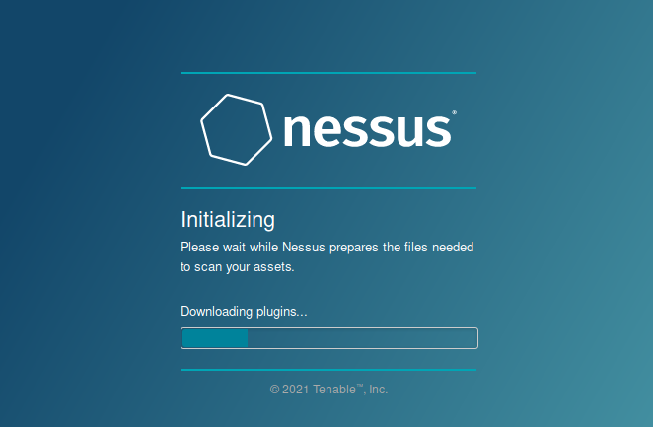

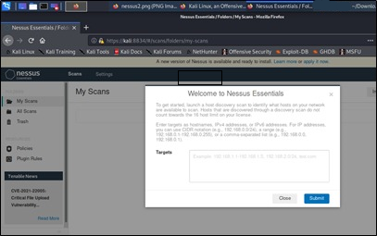

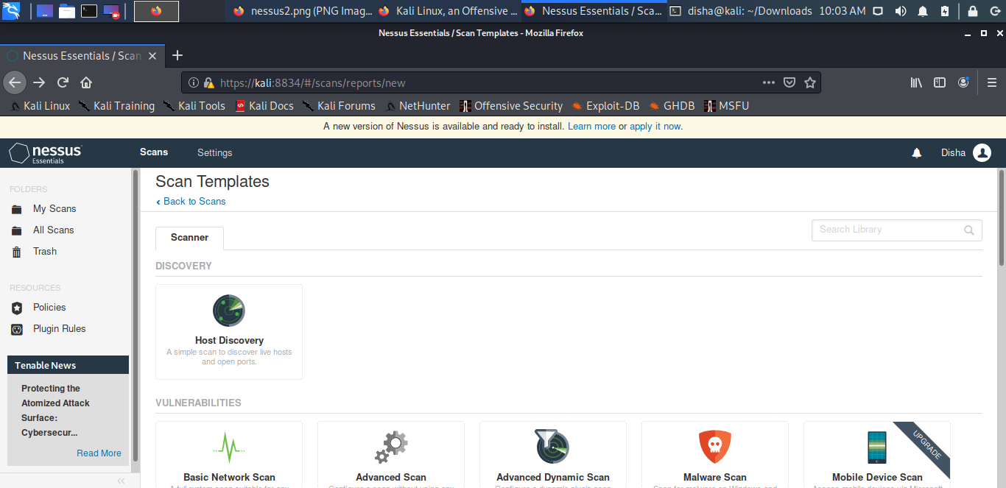

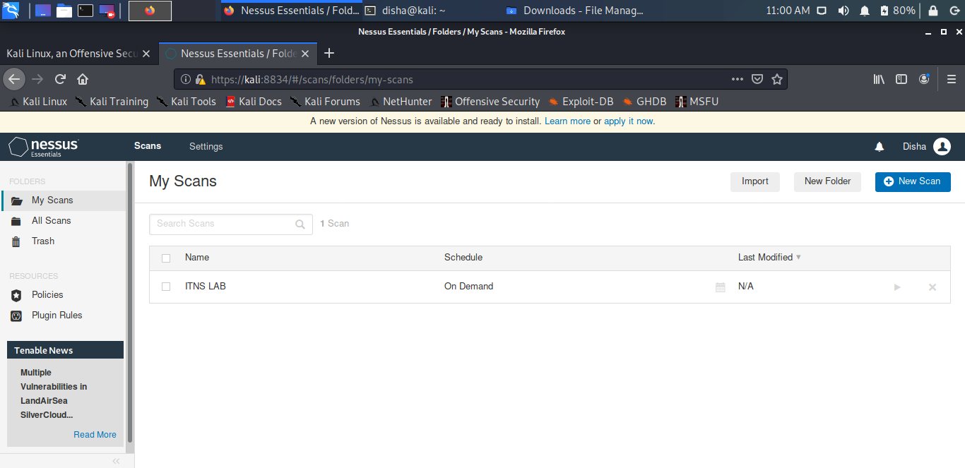

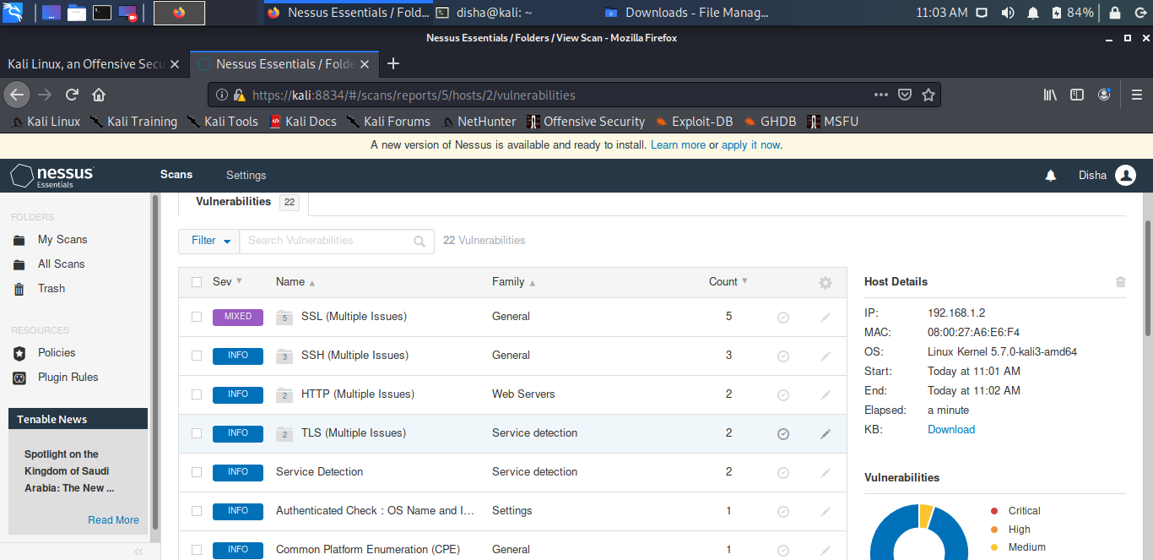

**Conclusion :**

The Nessus Vulnerability Scanner is one of the most common vulnerability scanners in the cybersecurity industry today. The functionality that you get, especially with the commercial version, is total guarantee of value for your money. While it is also important to confirm your vulnerability hits by running other vulnerability scanners against your targets to eliminate the possibility of any false positives, Nessus’s functions justify its popularity.

**EXPERIMENT – 5**

**AIM :** Study for network analyser tool – Wireshark and shown the password as snift.

1. Open the Wireshark.

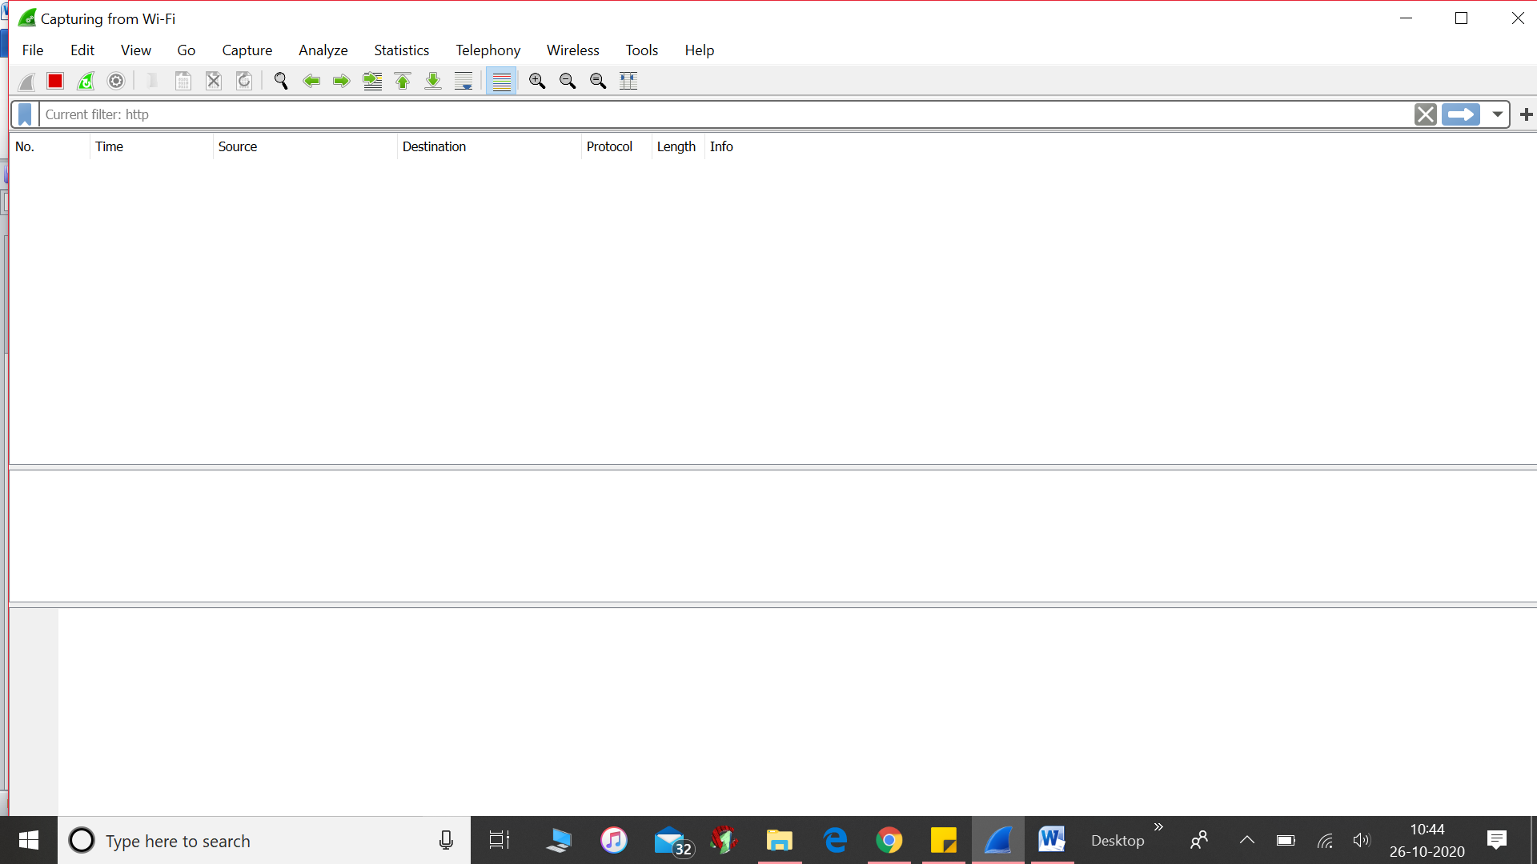

2. Choose the interface from where to capture the packets.

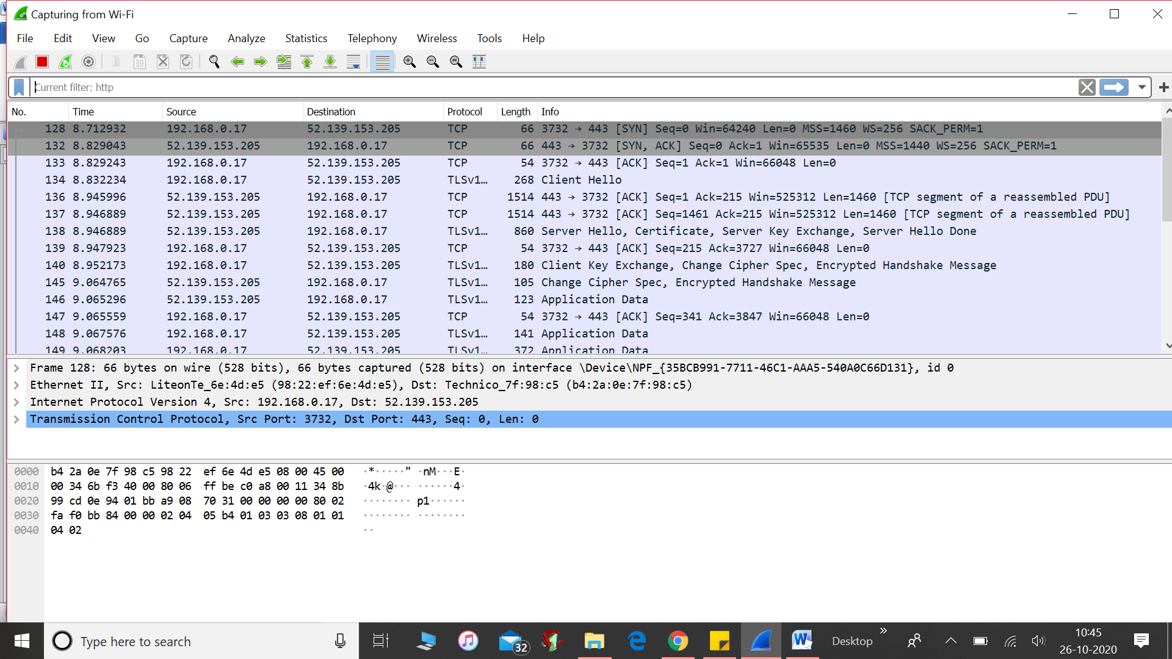

3. Start capturing the packets.

4. Goto login page of [www.techpanda.com](http://www.techpanda.com)

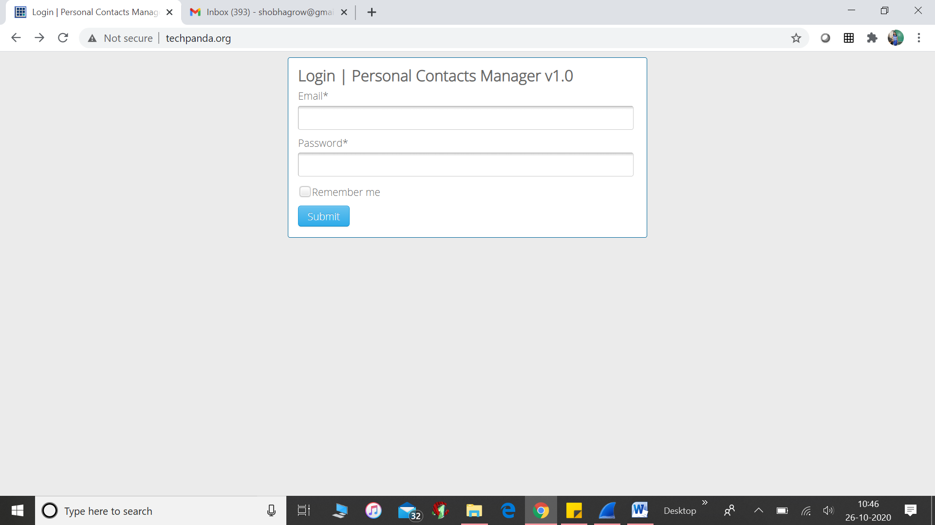

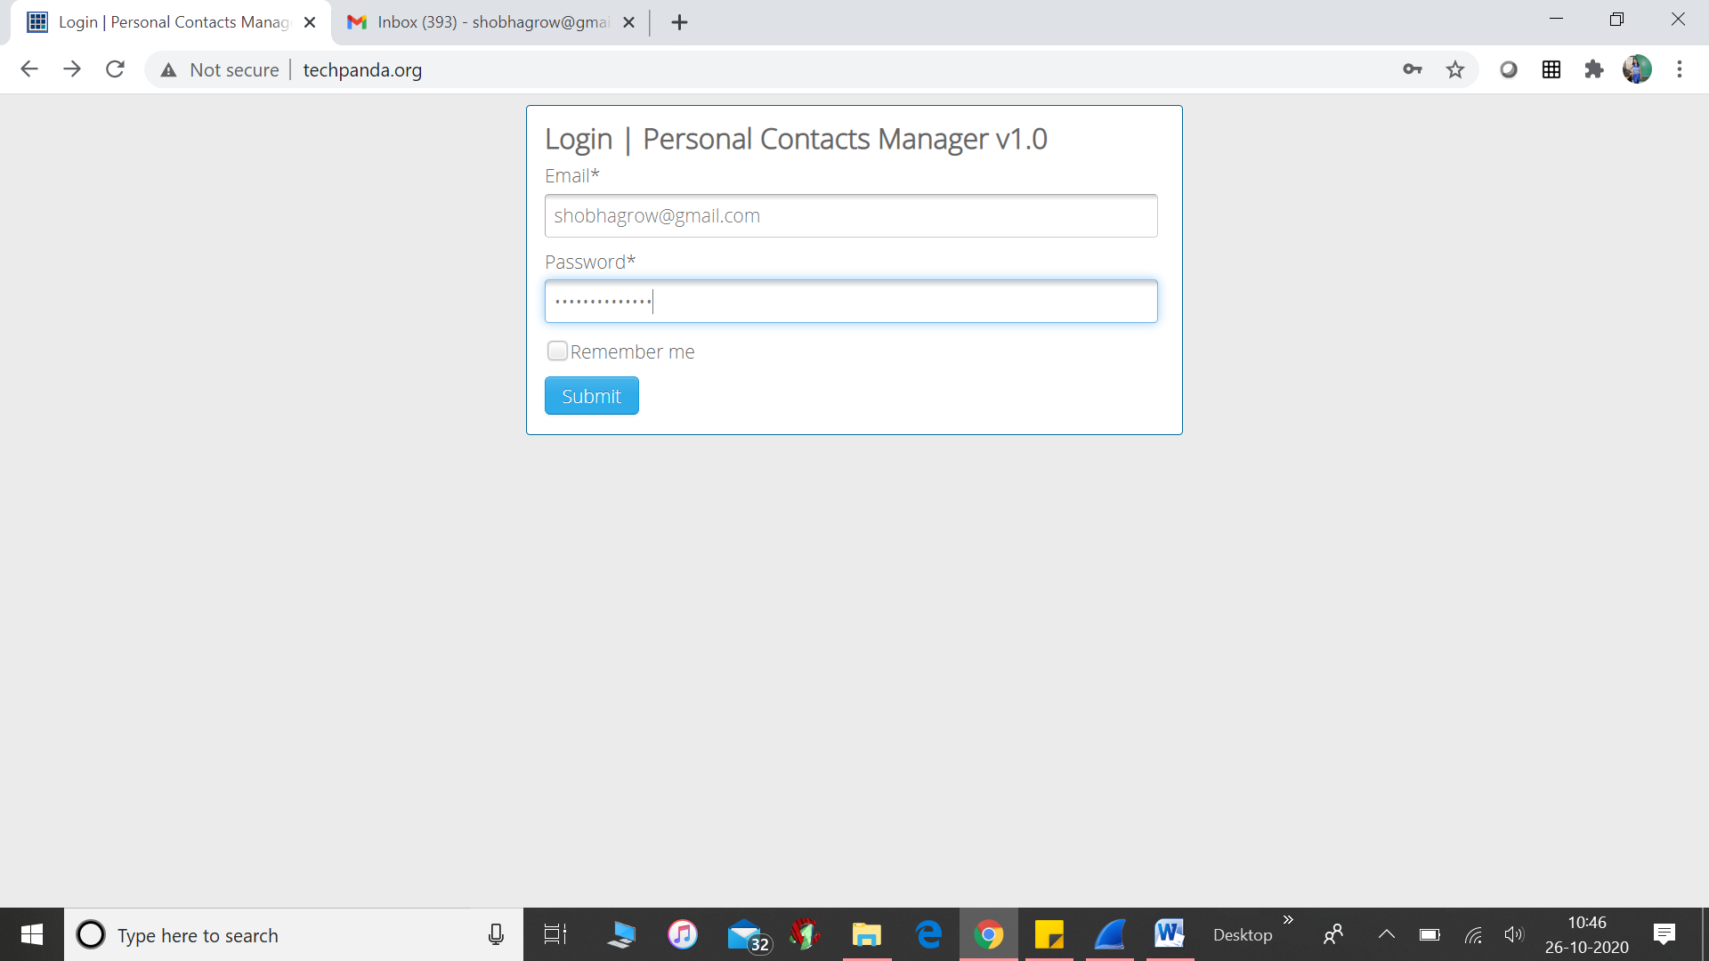

Now go to wireshark, stop capturing the packets

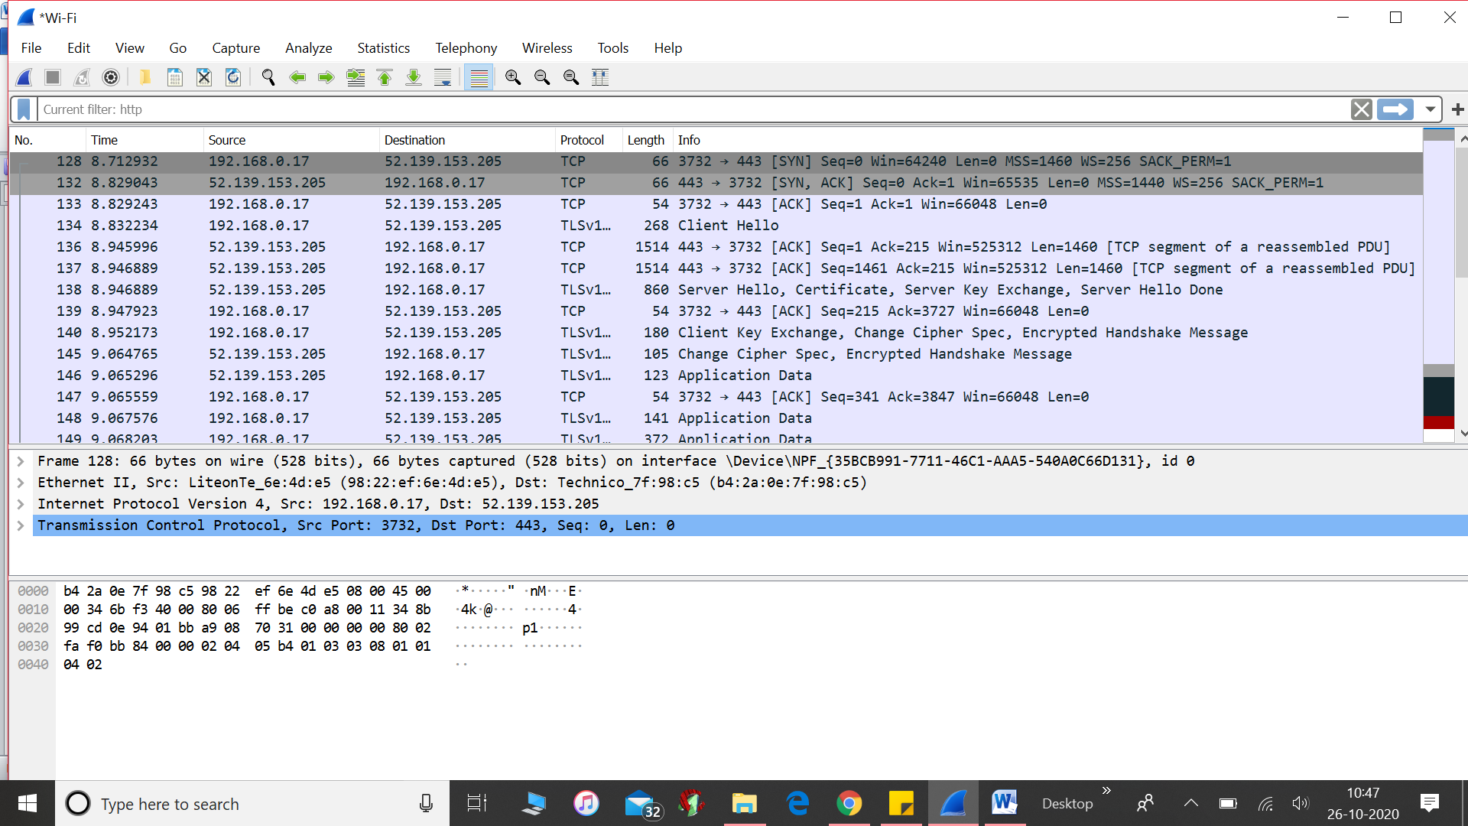

Apply filter http filter to see only http packets.

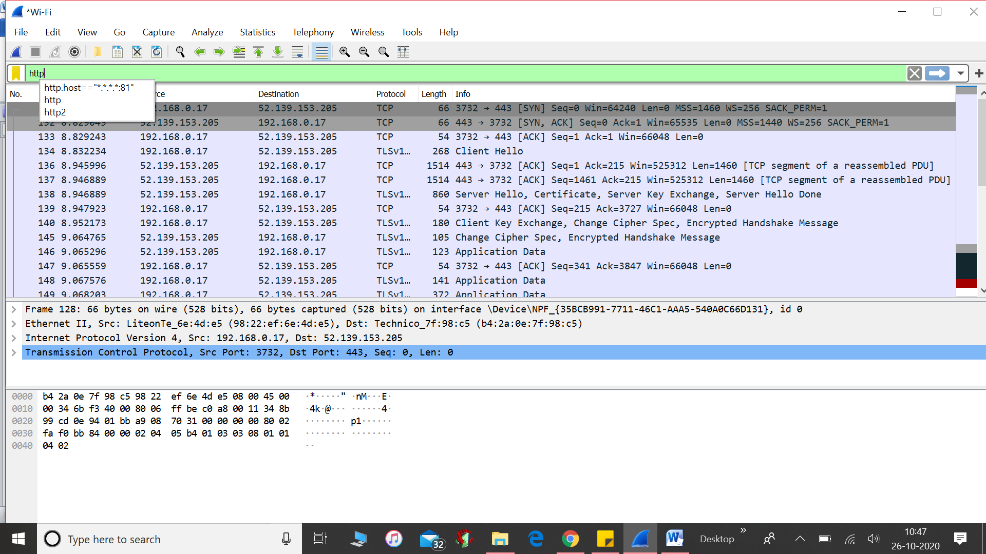

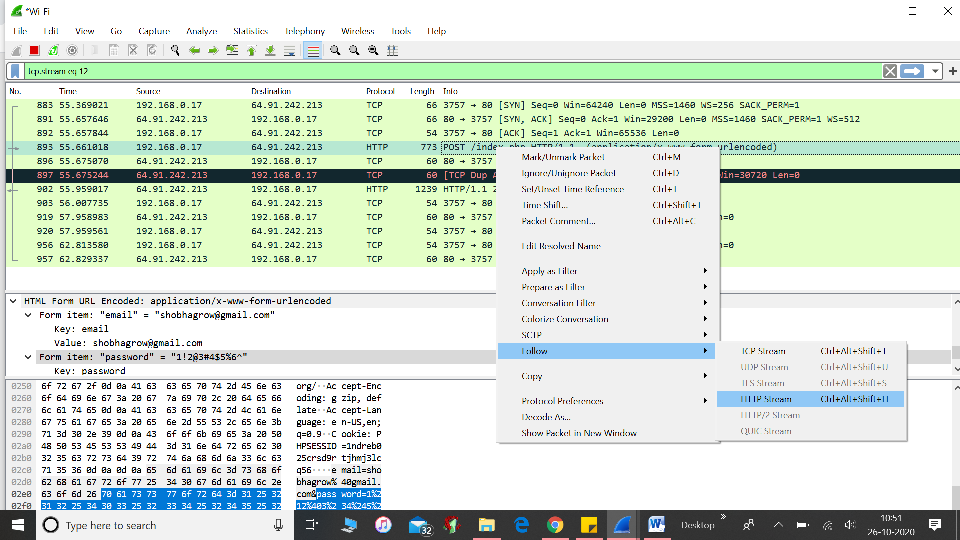

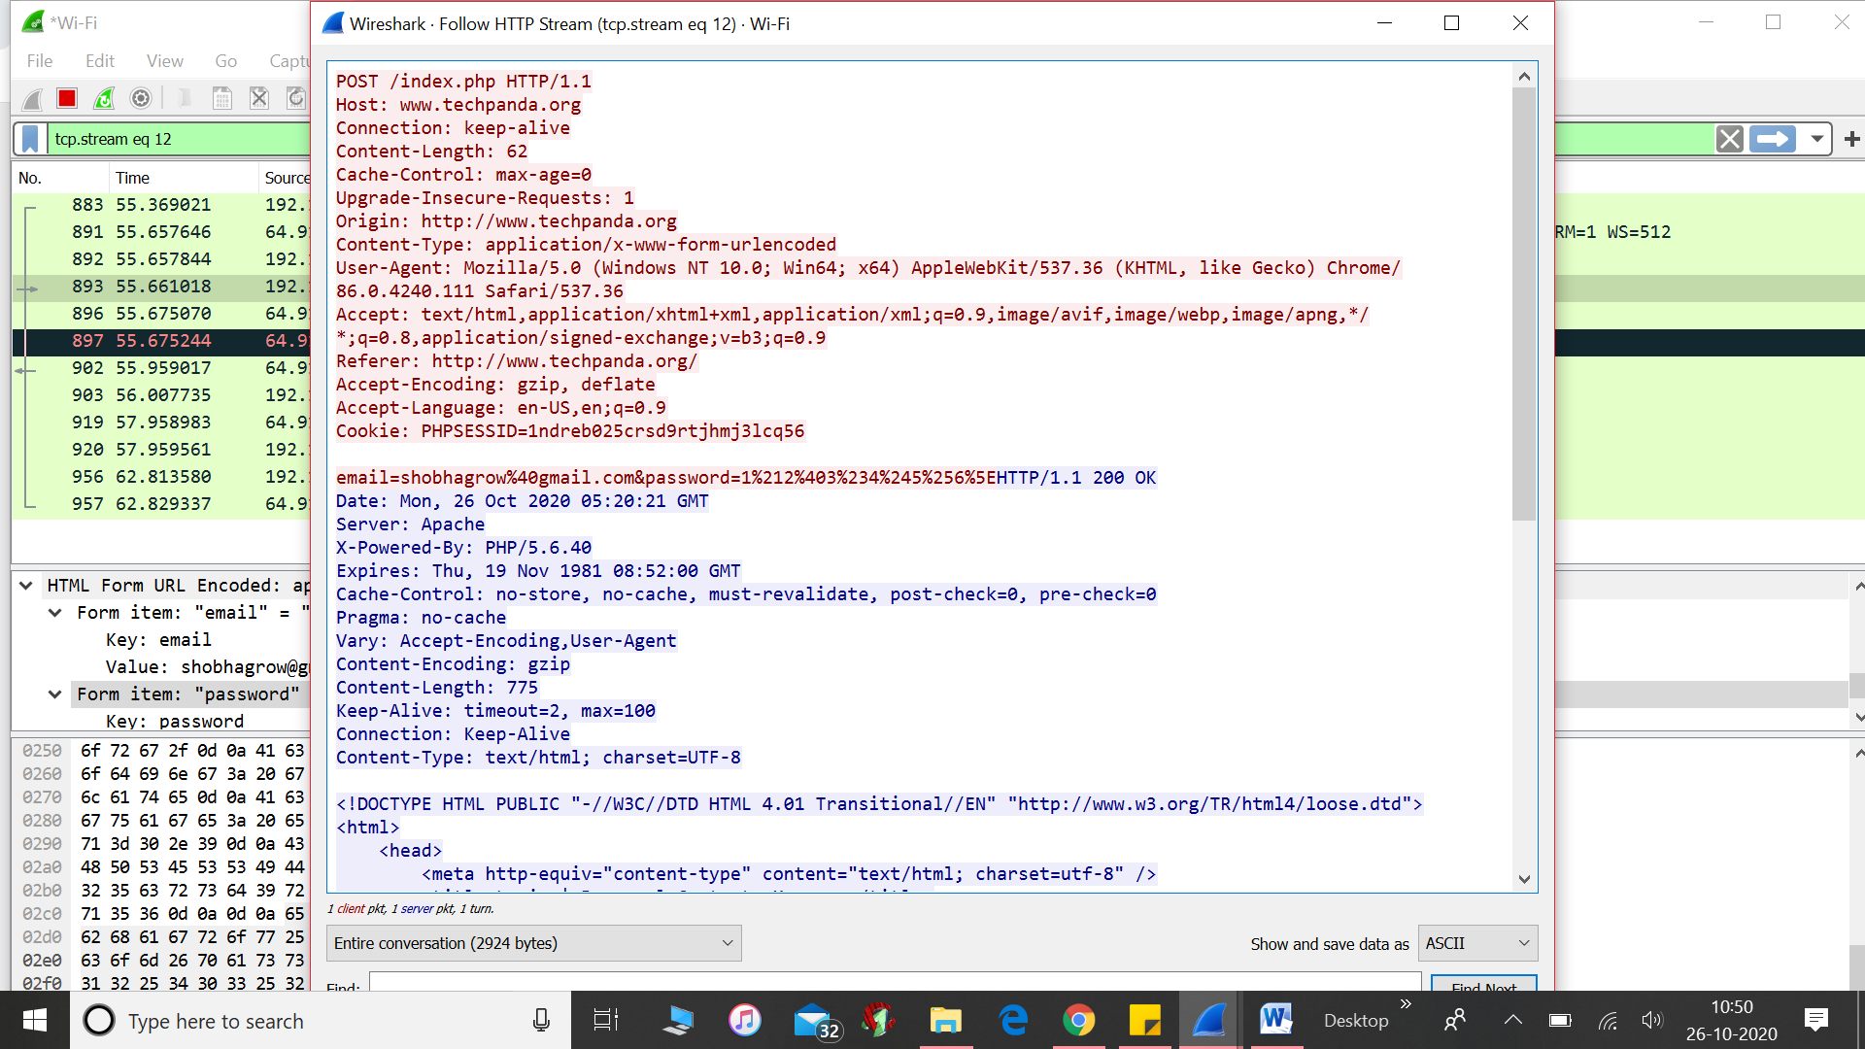

**Conclusion:**

Successful capturing of the packets using Wireshark.

**EXPERIMENT – 6**

**AIM:** Study of John the ripper tool and breach the security of protected files and folders.

Installation

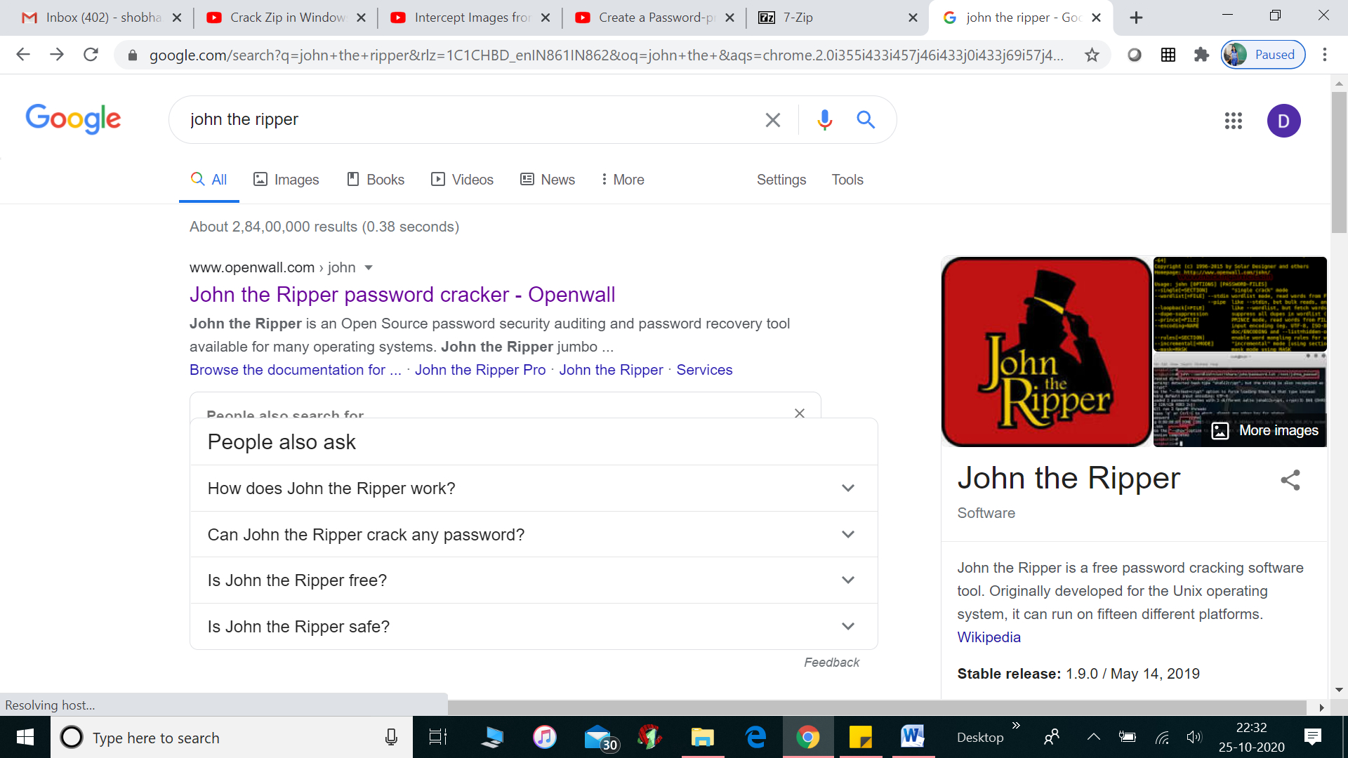

Step 1 select all the files that you want to place in compressed folder (under dowloads)

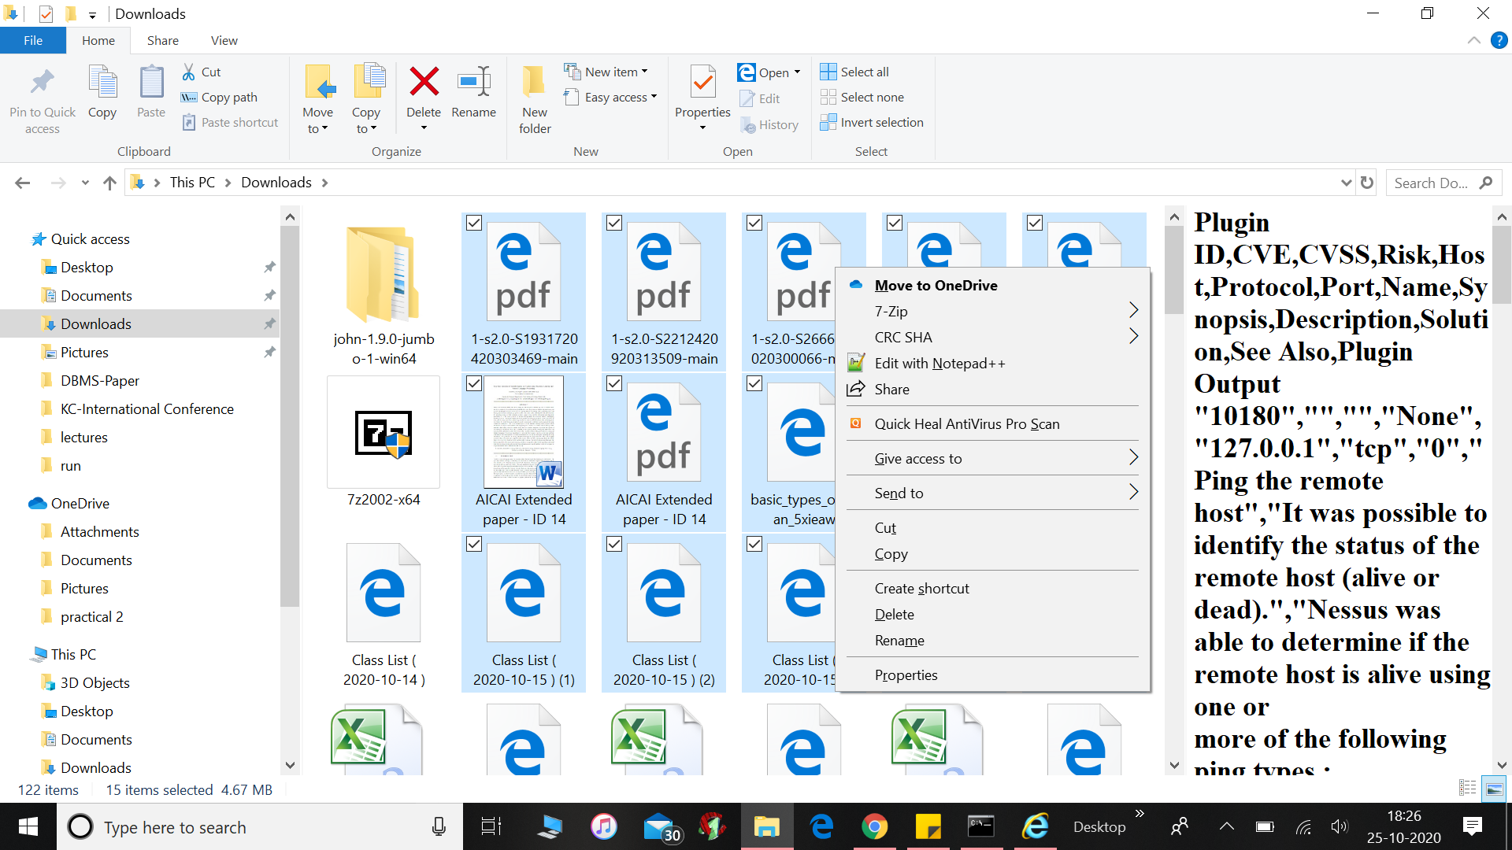

Step 2: right click at the selected folder and choose 7-Zip--🡪 add to archive

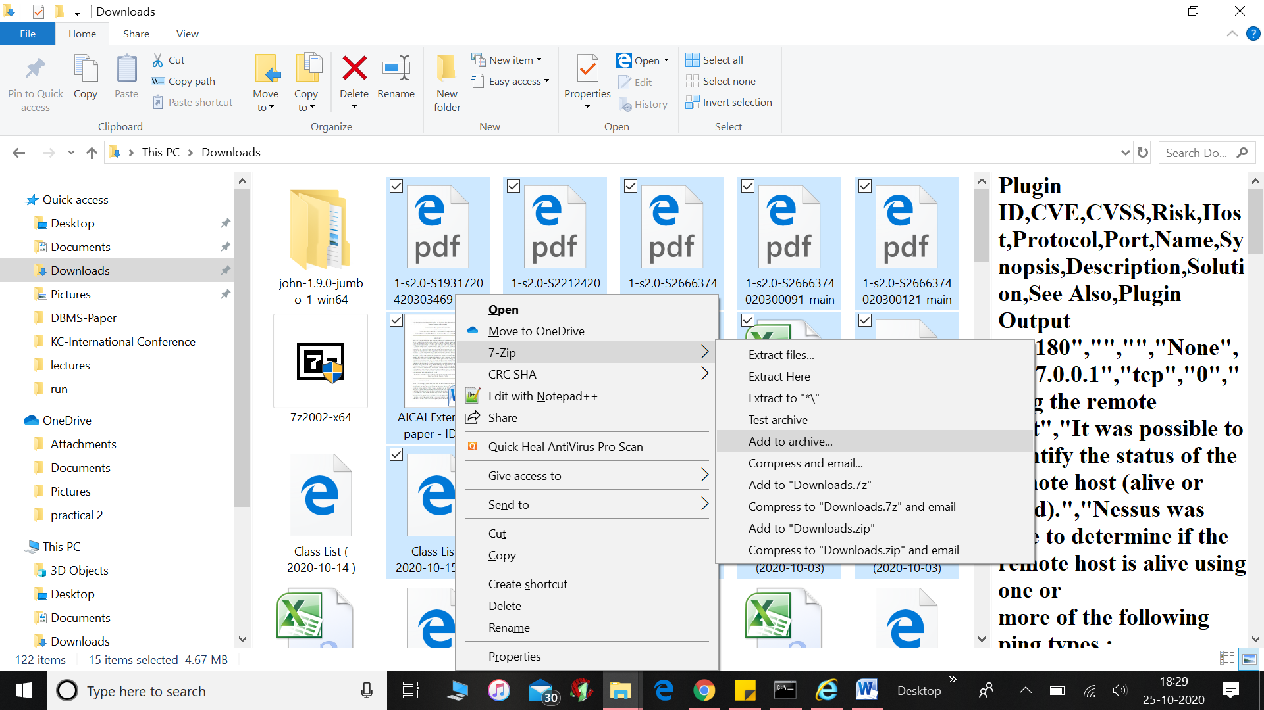

Step 3: Choose Add to archive--🡪 then fill the credentials like name of compressed folder, archive format as .zip, password and encryption method as Zipcrypto and finally click ok.

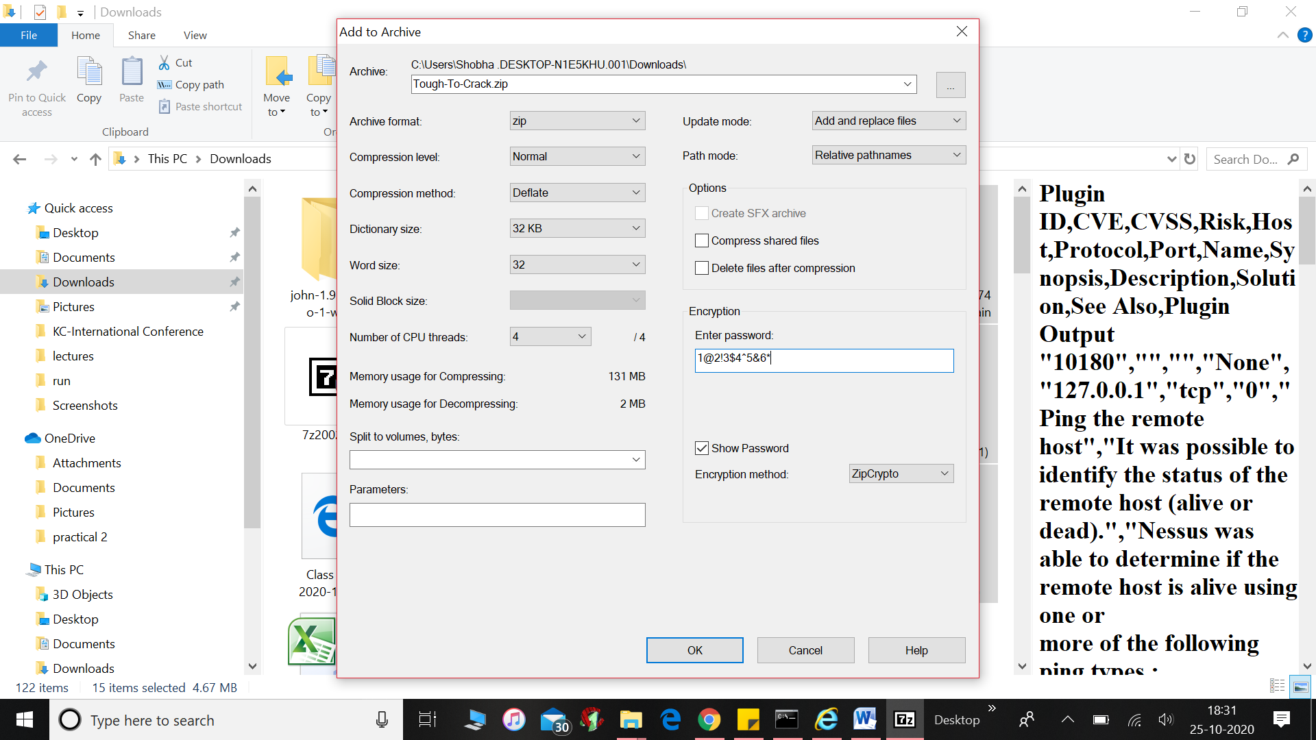

Step 4: cut the folder from downloads and put it into Run folder under John the ripper software.

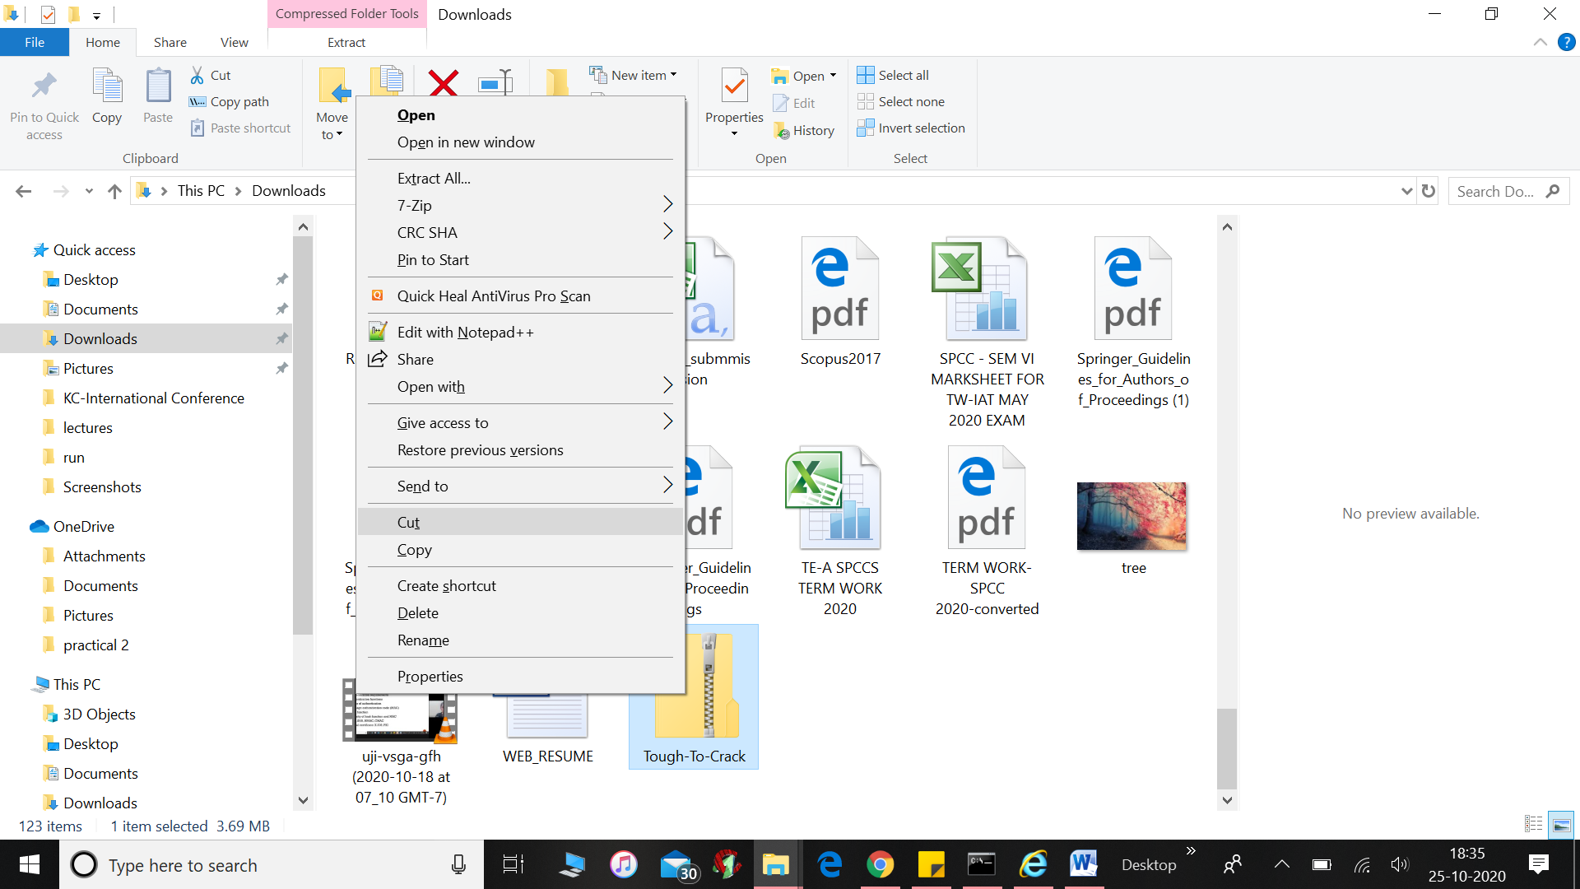

Step 5: choose john folder

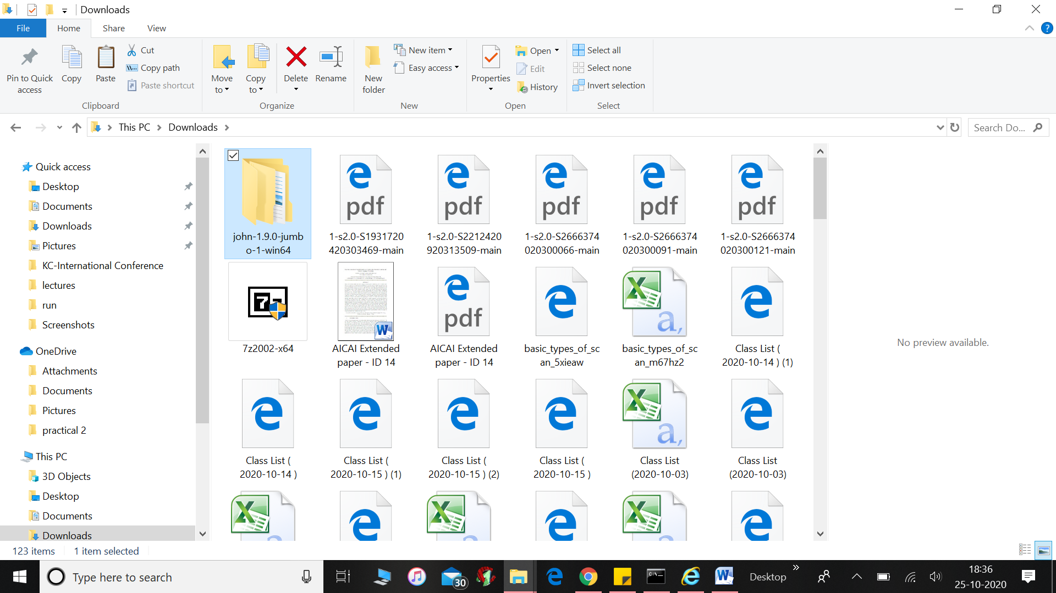

Click it

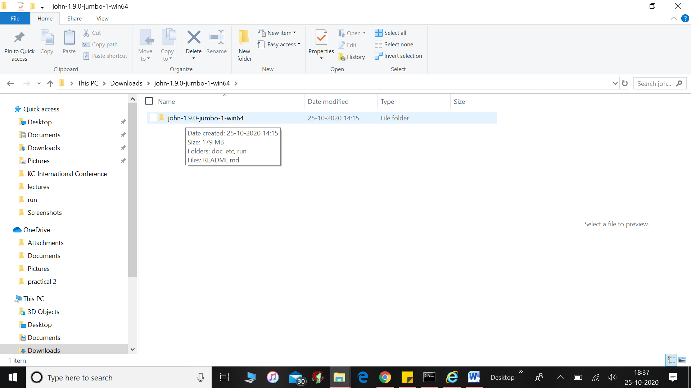

Click it further

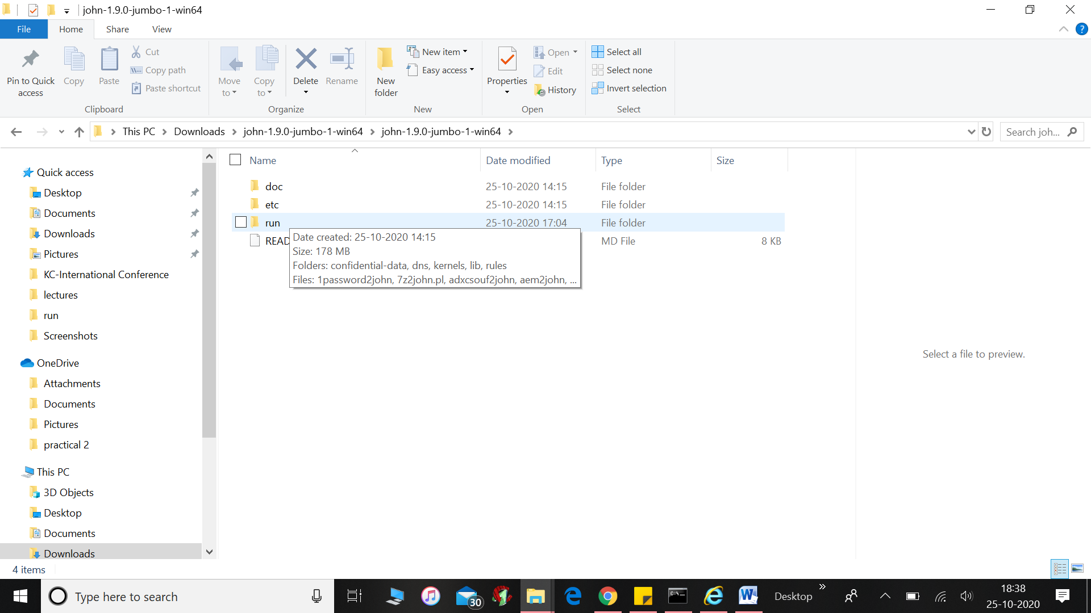

Choose run

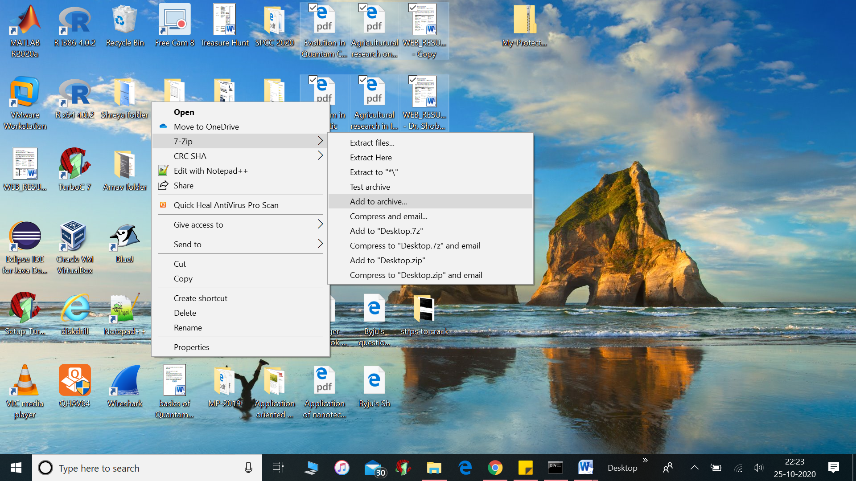

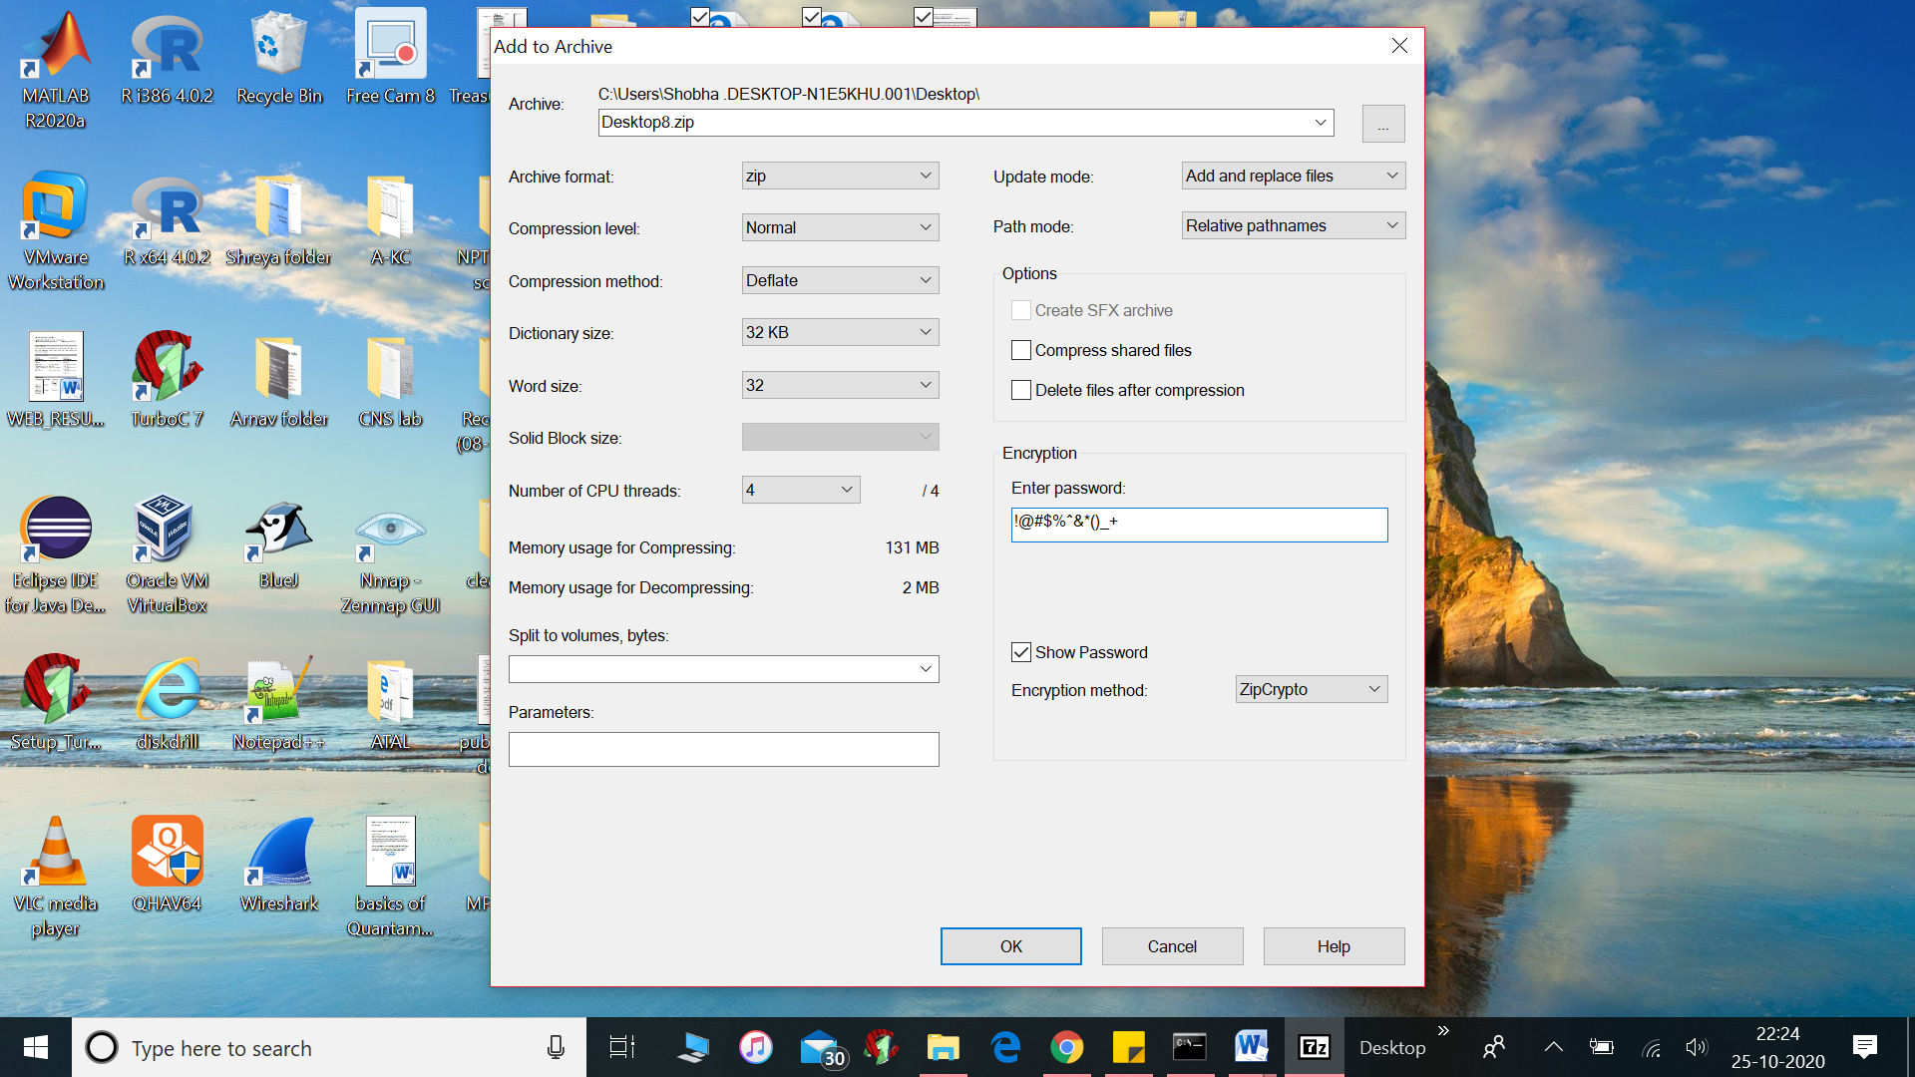

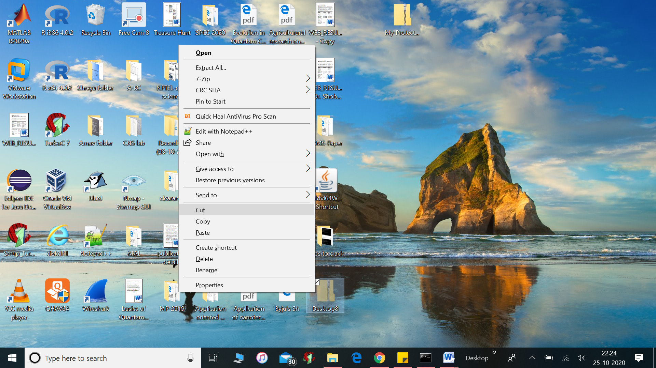

Desktop8.zip is placed in run folder

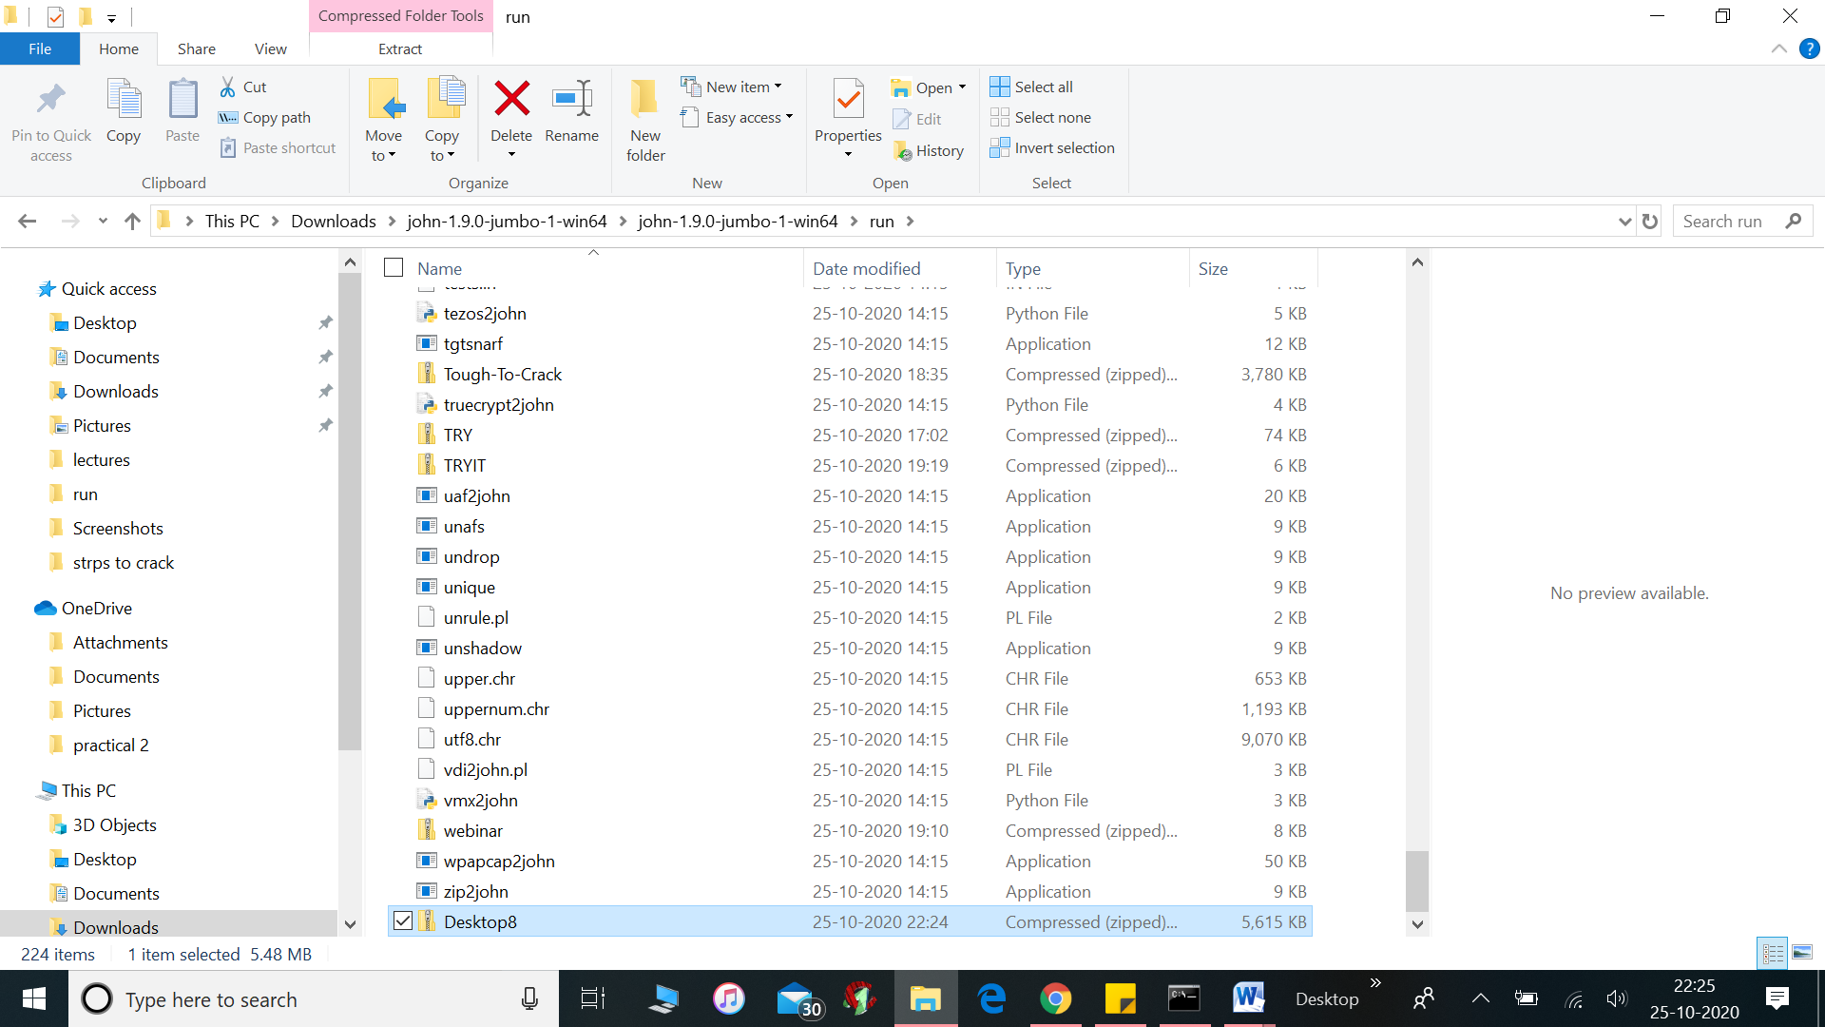

Then go to cmd under run only and click it

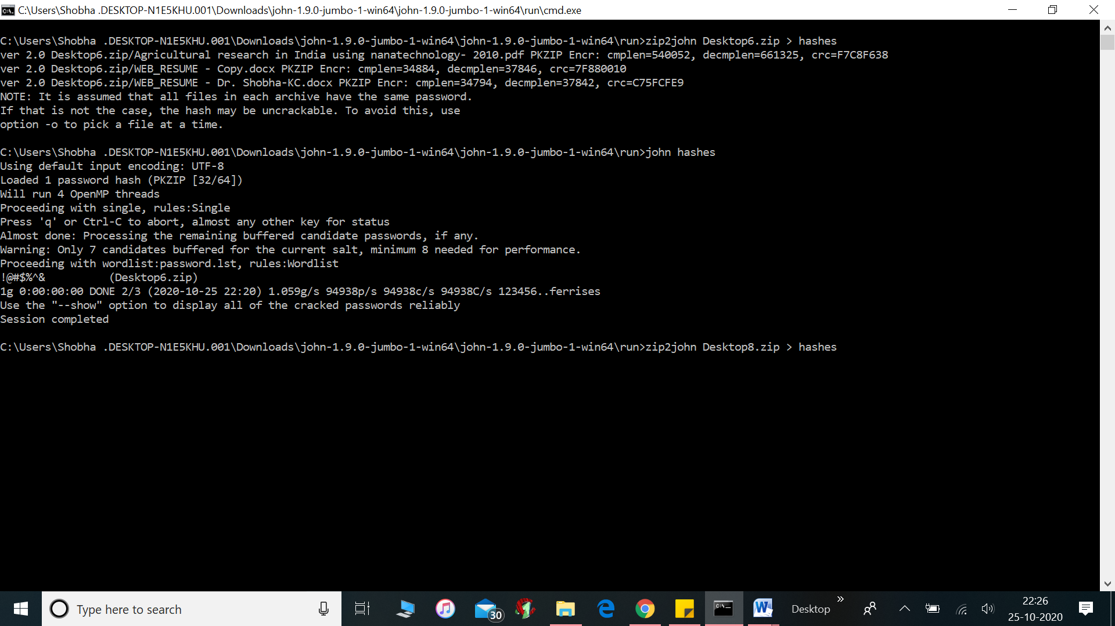

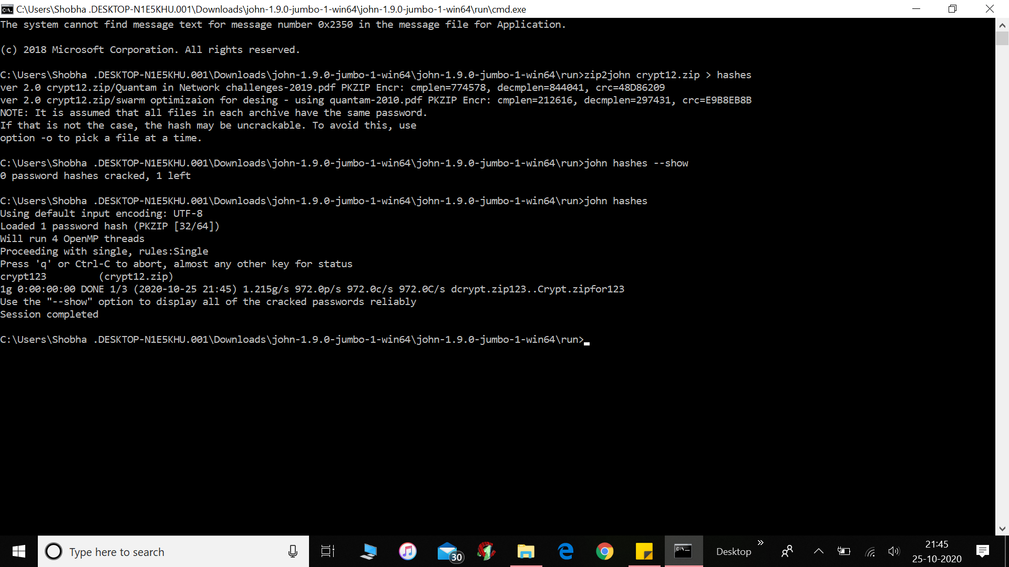

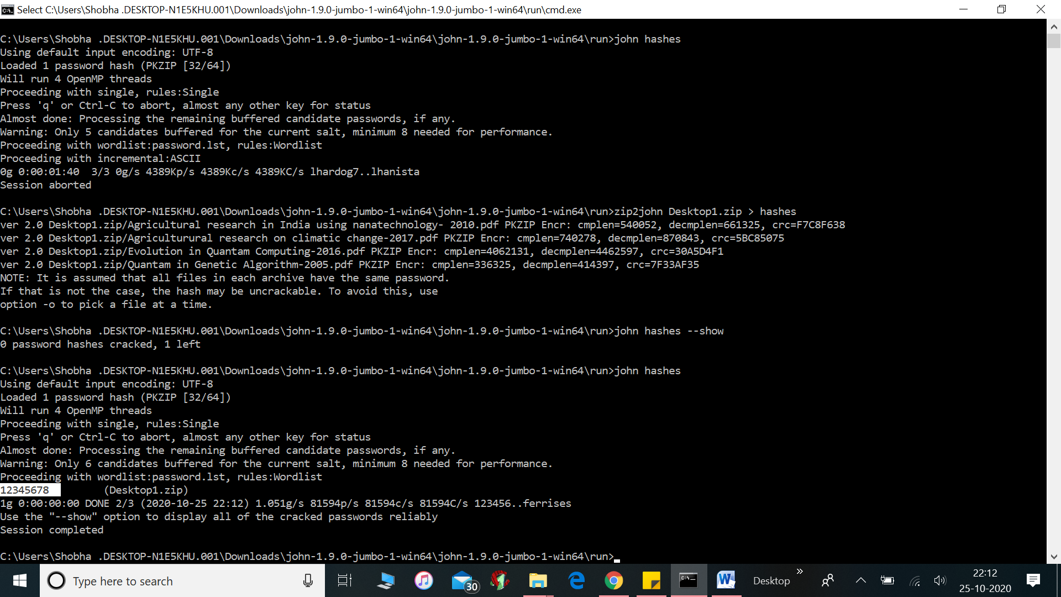

**Conclusion:**

Password cracking using the ripper tool was done successfully.

**EXPERIMENT NO – 7**

**AIM:** Implementation of File System Security.

**THEORY**:

VeraCrypt is a Free and Open Source utility used for on-the-fly encryption. It can create a virtual encrypted disk within a file or encrypt a partition or the entire storage device with pre-boot authentication. Individual ciphers supported by VeraCrypt are AES, Serpent, Twofish, Camellia, and Kuznyechik.

Additionally, ten different combinations of cascaded algorithms are available: AES–Twofish, AES–Twofish–Serpent, Camellia–Kuznyechik, Camellia–Serpent, Kuznyechik–AES, Kuznyechik–Serpent–Camellia, Kuznyechik–Twofish, Serpent–AES, Serpent–Twofish–AES, and Twofish–Serpent.

The cryptographic hash functions available for use in VeraCrypt are RIPEMD-160, SHA-256, SHA-512, Streebog and Whirlpool.

**STEPS OF PERFORMING FILE SECURITY**:

1. Open VeraCrypt tool and Click on the Create Volume.
2. Create a Standard Veracrypt volume.
3. From the select file menu, point to destination of created volume.
4. Choose the Encryption Option.
5. Create a password for said volume, be sure to use a complex password and never forget this password you set.
6. Move your mouse as randomly as possible, as tool will calculate hash based on mouse movement here, thus more random, more secure it will be once collection is complete click on the format and wait for the formatting of volume to finish.
7. Click on mount button and locate your newly create volume, once mounted it’ll show itself on the main screen.
8. Now the volume has been mounted, you can transfer your folder containing sensitive info into it like a normal drive, and once you unmount, the information in the volume created will no longer will be accessible to anyone.

**OUTPUT**:

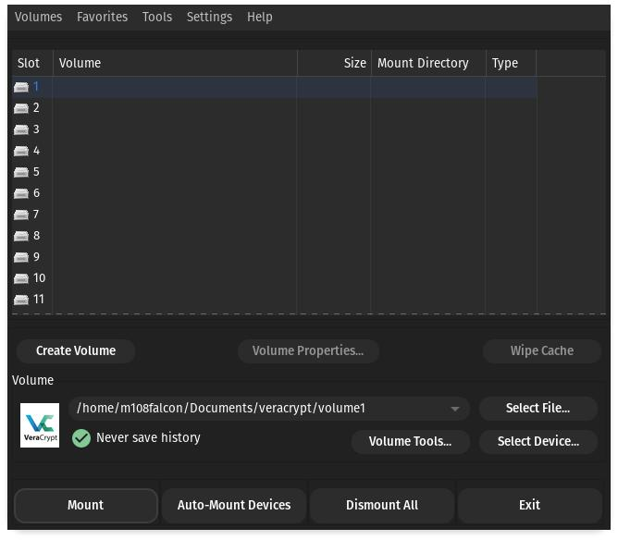

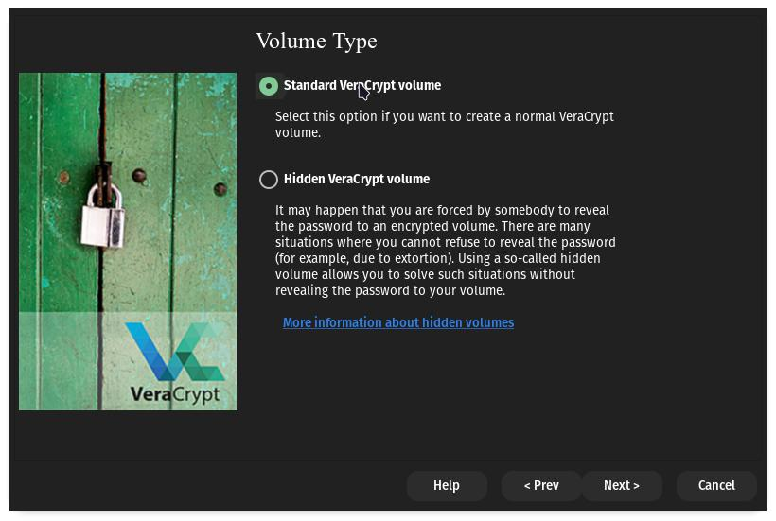

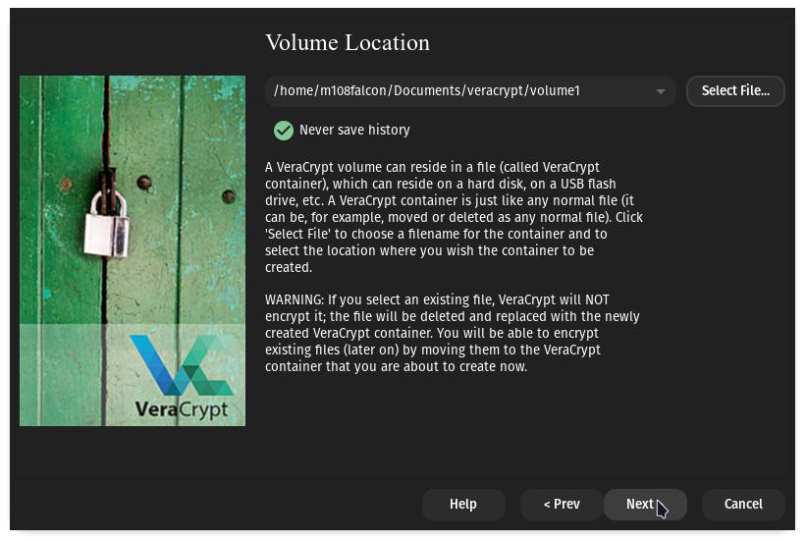

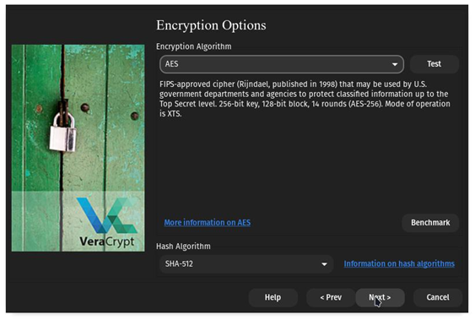

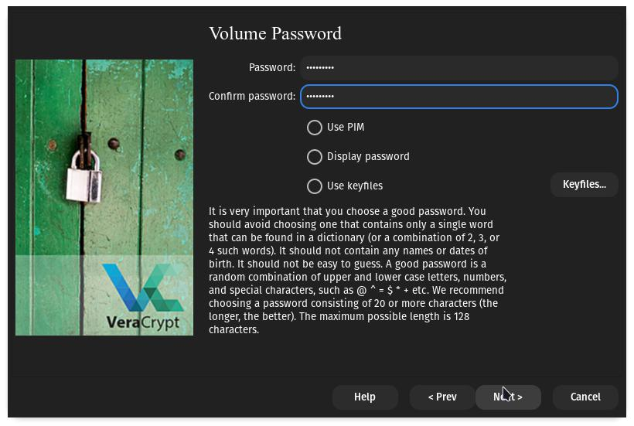

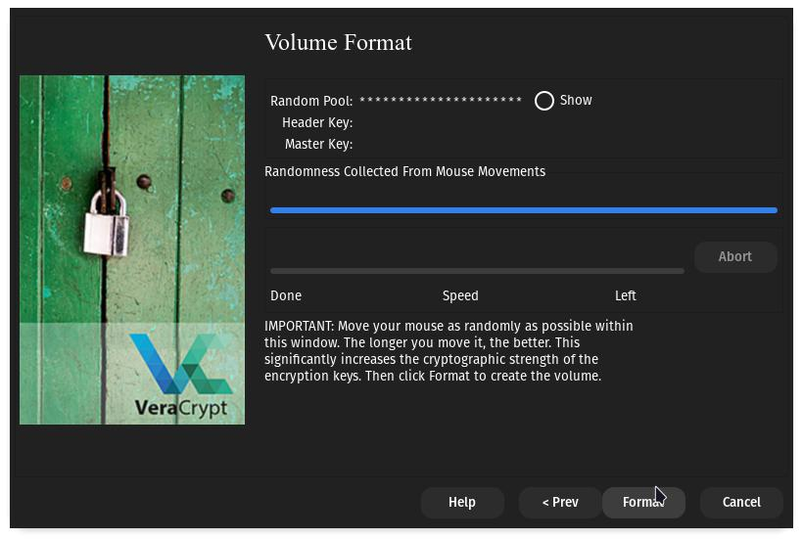

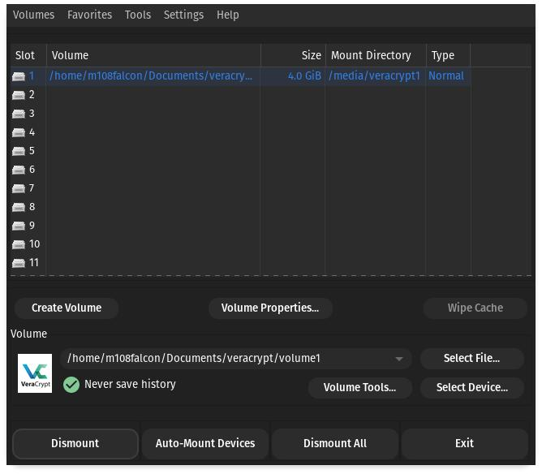

**Conclusion :**

The files were encrypted using VeraCrypt using AES ciphers was successfully done.

**EXPERIMENT NO – 8**

**AIM:** A case study on Cyberattack: Twitter Got Hacked

**THEORY**:

On July 15, 2020, a 17-year old hacker and his accomplices breached Twitter’s network and seized control of dozens of Twitter accounts assigned to high-profile users. For several hours, the world watched while the Hackers carried out a public cyberattack, by seizing one high-profile account after another and tweeting out a “double your bitcoin” scam. The Hackers took over the Twitter accounts of politicians, celebrities, and entrepreneurs, including Barack Obama, Kim Kardashian West, Jeff Bezos, and Elon Musk, as well as Twitter accounts of several cryptocurrency companies regulated by the New York State Department of Financial Services. And for several hours Twitter seemed unable to stop the hack.



In monetary value, the Hackers stole over $118,000 worth of bitcoin. But more significantly, this incident exposed the vulnerability of a global social media platform with over 330 million total monthly active users and over 186 million daily active users, including over 36 million (20%) in the United States. In short, Twitter plays a central role in how we communicate and how news is spread. More than half of U.S. adults get their news from social media “often” or “sometimes.”

Given that Twitter is a publicly traded, $37 billion technology company, it was surprising how easily the Hackers were able to penetrate Twitter’s network and gain access to internal tools allowing them to take over any Twitter user’s account. Indeed, the Hackers used basic techniques more akin to those of a traditional scam artist: phone calls where they pretended to be from Twitter’s Information Technology department. The extraordinary access the Hackers obtained with this simple technique underscores Twitter’s cybersecurity vulnerability and the potential for devastating consequences. Notably, the Twitter Hack did not involve any of the high-tech or sophisticated techniques often used in cyberattacks – no malware, no exploits, and no backdoors.

**How the attack happened?**

According to the details disclosed by the affected platform, Twitter employees became victims of social engineering as they were tricked into revealing privileged information to hackers. Twitter Support referred to this attempt as "coordinated social engineering attack" as hackers were successful in targeting some of Twitter employees who had access to internal tools and systems.

The leaked information was used by the attackers to gain access to Twitter's internal database and it also enabled them to circumvent the social platform’s two-factor authentication (2FA). Once the hackers were in the system, resetting passwords of verified accounts was not that big of a challenge. Attackers targeted 130 accounts but they were able to execute password reset for 45 accounts. The hackers were also able to harvest sensitive personal data of influential people including phone numbers, email addresses, and private messages.

The first handles that got compromised were Apple and Uber accounts followed by those of Bill Gates and Elon Musk. In a matter of a few hours, the attackers had successfully taken over the Twitter accounts of Jeff Bezos, Barack Obama, Mike Bloomberg, and Joe Biden.

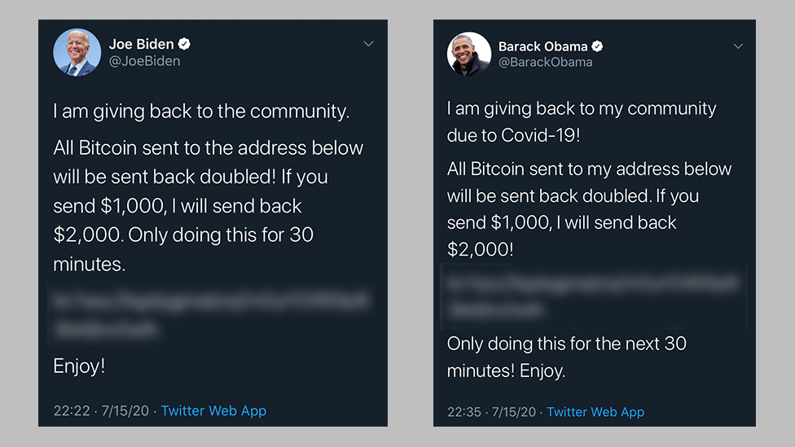

It is interesting to note that political and technology figureheads were not the only ones who were impacted. Sportsmen like Floyd Mayweather and pop culture icon Kim Kardashian also became the victims of the attack. This forced Twitter's hand to lock most of the verified handles across the United States and the world.

**Weak Links that Enabled the Attack -**

Modern hacking revolves around exploiting weaknesses in the system instead of brute-forcing your way through them. Despite a major shift in focus towards both enterprise and consumer cybersecurity and privacy, our identities remain weak due to the following reasons.

* Passwords - A combination of characters that someone knows. It is a weak spot because passwords rely on human intelligence and constant vigilance. Any lack in either of those aspects can lead to exposure of sensitive information.
* Phishing - Although many people can identify phishing attacks, ones that are more sophisticated are quite challenging to decipher, especially when they are used in combination with social engineering. Attackers gain your confidence and pick on your vulnerability to trick you into sharing information they are not privy to.
* Centralised Databases - They are single-point failure systems as once a hacker is in, they gain access to pretty much anything they want. And before you find out about the attack and identify its nature and scope, the damage has already been done. Not unlike what happened in Twitter's hacking fiasco.

**Consequences of the Attack -**

* Hackers were able to take over influential accounts which could have been far more disastrous for the financial and political parts of the world. Fortunately, the attackers’ scam was quickly stopped by the coordinated effort of Twitter and the major cryptocurrency exchanges.
* High-profile identities were stolen which again could have been used to enact conspiracies with far-reaching political and financial consequences.
* The hack did not only cause financial and reputational damage to the social media platform but for its victims it meant losing untraceable money (crypto currency).

**How to Prevent Such Attacks**

In order to reduce the chances of major security breaches in the future, companies need to adopt a system that relies on zero trust, zero knowledge, and zero personally identifiable information (PII) based security architecture. All of these features will enable the next-generation security technology designed to ensure that the end user is always authentic. They key features would include:

* Password-less authentication which means social engineering or phishing attempts cannot be successful
* Even if there is a phishing or account takeover attempt, there is built-in prevention within the architecture that keeps sensitive data and information safe and secure.
* There is no centralized database where all the credentials are stored as authentication information is either biometric-based and generated on the edge device.
* Privileged insider threat prevention which ensures human error or negligence does not get in the way of your cybersecurity initiatives.
* Using this modern security architecture allows you to deploy multi-party authorisation which substantially reduces the odds of a lone attacker or rogue insider compromising the entire system.

**Conclusion**

In a matter of hours, the people behind the Twitter attack were not only able to compromise multiple high-profile accounts but sent out tweets that allowed them to defraud thousands of people successfully. Many would point fingers towards Twitter employees and the lax nature of security initiatives by the social platform itself, but the underlying causes were the weak links present within currently prevalent security architecture and procedures, which are used by all companies worldwide.

Humans will always be susceptible to making mistakes, going rogue, or being emotionally manipulated. The end goal should be to put a superior security architecture on top of them that strengthens inherent security by eliminating our reliance on the weak links that can be exploited. Zero trust, zero knowledge, and zero personally identifiable information (PII) based security architecture is the way to go if we are to prevent large-scale security breaches in the future.

**EXPERIMENT NO – 9**

**AIM**: Implementation of Cryptography Lab: Symmetric and Asymmetric Encryption

**THEORY**:

Symmetric key cryptography is any cryptographic algorithm that is based on a shared key that is used to encrypt or decrypt text/cyphertext, in contract to asymmetric key cryptography, where the encryption and decryption keys are different. The keys may be identical, or there may be a simple transformation to go between the two keys. Symmetric-key encryption can use either stream ciphers or block ciphers.

1.Stream Cipher encrypt the digits (typically bytes), or letters (in substitution ciphers) of a message one at a time.

2.Block Cipher take a number of bits and encrypt them as a single unit, padding the plaintext so that it is a multiple of the block size.

Implementation of DES: Disk Encryption System

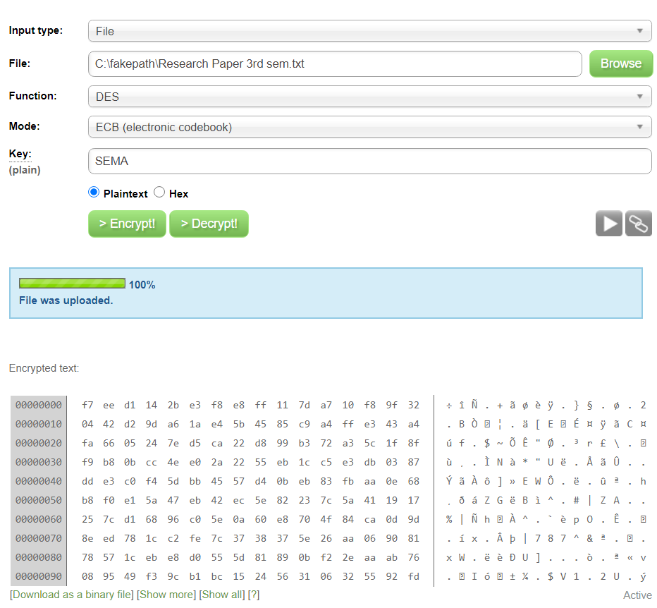**Encryption:**

**Decryption:**

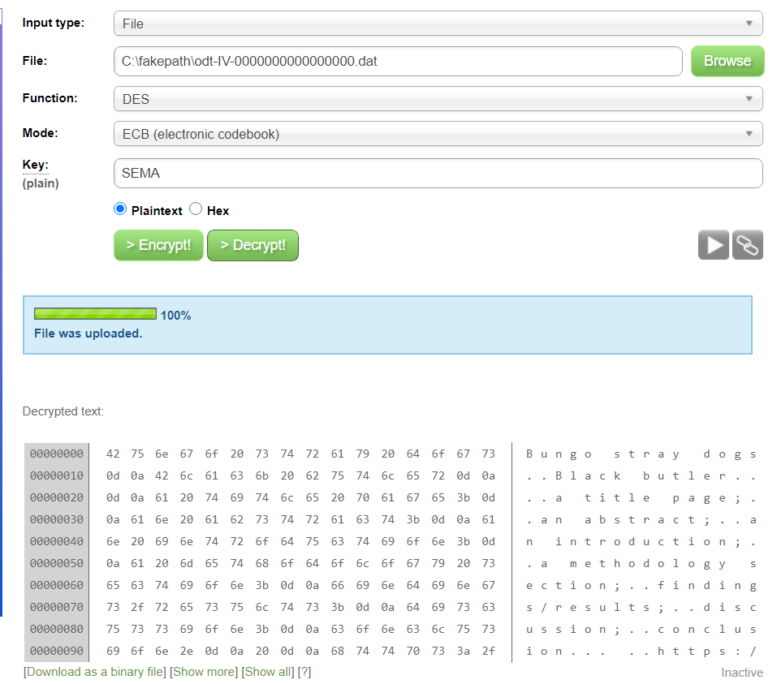

Asymmetric cryptography is a branch of cryptography where a secret key can be divided into two parts, a public key and a private key. The public key can be given to anyone, trusted or not, while the private key must be kept secret (just like the key in symmetric cryptography).

Asymmetric cryptography has two primary use cases: authentication and confidentiality. Using asymmetric cryptography, messages can be signed with a private key, and then anyone with the public key is able to verify that the message was created by someone possessing the corresponding private key.

**Implementation of AES: Advanced Encryption Standard**

Encryption and Decryption:

